Antimicrobial Resistance (AR) Option Data Validation

The following guidance can be used by facilities undergoing the initial set up and implementation for reporting to the NHSN AR Option as well as on an annual basis or by those who underwent a change in vendor system. The NHSN AR Option Team developed these questions to focus validation efforts on key AR Option protocol definitions and Clinical Document Architecture (CDA) requirements including sources of error. Your facility can complete this document to confirm data accuracy and guide discussions with the vendor in the case of data discrepancy. If errors are identified in the AR Option data, please reach out to the relevant vendor (such as Electronic Health Record system [EHRs] or third-party AR surveillance system) to discuss and resolve them. Some questions may require consulting with other stakeholders within your facility such as the microbiology lab, stewardship team, infection prevention, and/or IT. Your facility can complete validation over the course of multiple sessions. Please refer to the NHSN AUR Module Protocol for a review of applicable definitions.
Important links are at the end of the document.
Please email questions to the NHSN Helpdesk: NHSN@cdc.gov.

Validation Checklist
 | Page | Complete
General understanding of AR Data being shared with NHSN | 2 | ☐
Data specifics & Data suppression | 2 | ☐
Candida species susceptibility testing | 4 | ☐
Review AR Option Data | 4 | ☐
Using the AR Option Event-level Line Listings | 4 | ☐
Using the AR Option Bar Chart | 6 | ☐
Using the AR Option Antibiogram | 6 | ☐
Using the AR Option AR Organism Rate Table | 8 | ☐
Using the AR Summary Data Line List | 8 | ☐
Compare AR Summary Data with Other NHSN Summary Data | 9 | ☐
Compare denominators | 9 | ☐

General Understanding of AR Data being shared with NHSN
It is important to understand what data your facility can and cannot send before validating the AR data sent to NHSN. These next few questions may require a discussion with your colleagues in the lab and review of AR Option data submitted to NHSN.
- The below diagram provides an example AR susceptibility data flow between clinical information systems.
  - Question: Are the AR Option data sent from your facility to NHSN coming from an Electronic Health Record system (EHRs), third-party AR surveillance system, or directly from your Laboratory Information System (LIS)?

  - Question: If data are sent into NHSN from your third-party AR surveillance system, then determine whether the data are being sent to the third-party AR surveillance system directly from the LIS, from the EHRs, or both.

A facility may have a different configuration depending on if they use a third-party AR surveillance system (an electronic AR surveillance system which is provided by a vendor that is different from the EHRs and LIS vendors).
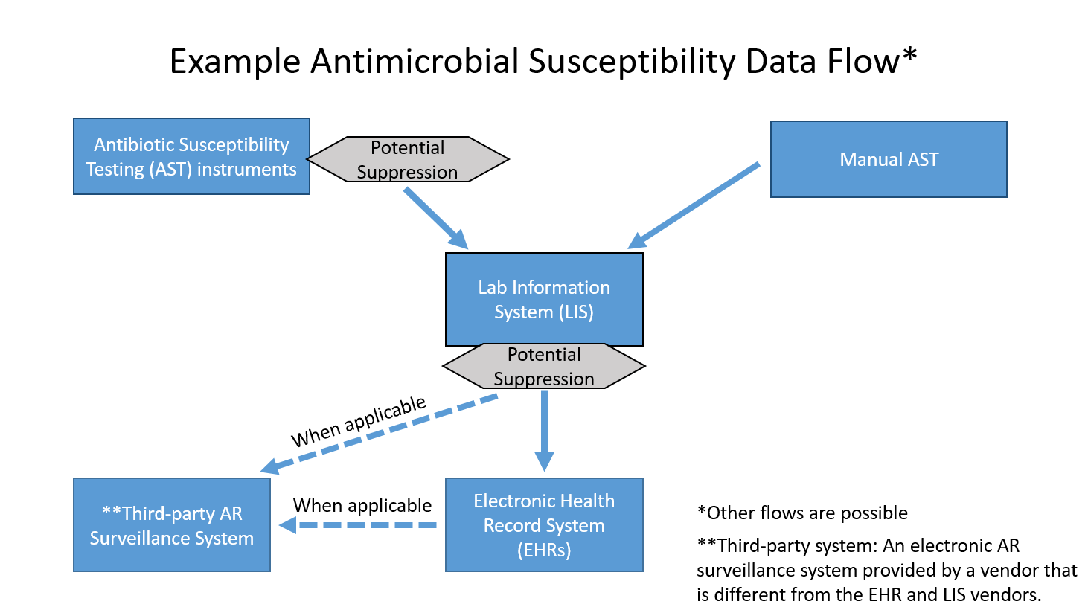
- Question: In general, does your facility perform data suppression for antimicrobial stewardship purposes (for example, selective or cascade reporting) through suppression of antimicrobial susceptibility results? Suppression occurs when antimicrobial resistance data are suppressed or withheld from clinical end users.

This section involves reviewing AR Option data uploaded into NHSN using available NHSN AR Option analysis reports. Prior to running any analysis report, remember to first generate new data sets within NHSN by following these steps:
- Click “Analysis”, “Generate Data Sets” and then “Generate New”.
Once the data sets have been generated, navigate to the analysis reports by following these steps:
- Click “Analysis” then “Reports”.
- On the Analysis Reports page, click “Antimicrobial Use and Resistance Module” and “Antimicrobial Resistance Data” to view available AR Option reports.

Answer the questions below using the report titled: Line Listing – All Antimicrobial Resistance Events. Use the Analysis Quick Reference Guide (QRG) for tips on how to make modifications.
- Question: Are the antimicrobial susceptibility results from your facility being suppressed prior to being sent to NHSN?

Suppression of data may be more likely if your facility is reporting data into the AR Option from a third-party AR surveillance system or EHRs due to how the susceptibility data are provided to these systems. If possible, obtain a list of all pre-suppressed susceptibility results from the Lab for the AR Option organisms specified in the AUR Module protocol to compare to the AR Event data uploaded into NHSN. If suppression is occurring, communicate with the vendor being used to submit AR Option data to NHSN to explore options of obtaining complete AR data (instead of suppressed data) for NHSN surveillance purposes, while data for clinicians continue to be suppressed per local antimicrobial stewardship policy.
If results are not suppressed prior to being sent to NHSN, skip to Question #4.
- Question: In the event the AR Event data being sent to NHSN are affected by suppression, do the NHSN AR Event data contain at least the same antimicrobial susceptibility information provided to the clinician within the patient record? NHSN recommends sending at least the same susceptibility information provided to the clinician.

- Question: Is the annual facility antibiogram produced by your laboratory affected by suppression or does the lab include all susceptibility data from all tests completed? We recommend contacting your Lab Director for confirmation.

- Question: Are specific test results (specifically, E-test, MIC, and Disk Diffusion) included in the data being sent to NHSN or is it just the final interpretation for each drug? NHSN recommends sending all specific test results for each drug if available.
Tip: To see these variables in the AR Event Line List, please add them on the modification screen.
Use the AR Event Line List Analysis QRG for an example.

- Question: Does your lab perform susceptibility testing either on or offsite, on Candida species (either routinely or on an as needed basis)?

- Confirm: If yes, review the AR Event Line List to confirm susceptibility data for Candida species have been reported.

Review AR Option Data
This section involves reviewing AR Option data uploaded into NHSN using available NHSN AR Option analysis reports. Prior to running any analysis report, remember to first generate new data sets within NHSN by following these steps:
- Click “Analysis”, “Generate Data Sets” and then “Generate New”.
Once the data sets have been generated, navigate to the analysis reports by following these steps:
- Click “Analysis” then “Reports”.
- On the Analysis Reports page, click “Antimicrobial Use and Resistance Module” and “Antimicrobial Resistance Data” to view available AR Option reports.

Using the NHSN Event-level Line Listings
Answer the questions below using the report titled: Line Listing – All Antimicrobial Resistance Events. Use the Analysis QRG for tips on how to make modifications.
Tip: If you receive a message saying there are too many rows to display, modify the report and use filters to see only the desired organisms, months, or locations. Alternatively, export the entire analysis data set.
- Question: Have AR Events been reported from all expected inpatient locations? Consider matching data from the AR Event Line List to your NHSN Locations list (Facility → Locations → Find).

If AR Events from specific locations are missing from the AR Line List, review the LIS to determine if specimens were collected in those locations for that time period. Expect fewer specimens to be collected in locations such as well baby nursery, labor & delivery, behavioral health, and rehabilitation.

- Question: Is your facility reporting AR Events from your Emergency Department and 24-hour observation location (if applicable)? If yes, do these events appear on the line listing? If AR Events from these locations are missing from the AR Line List, review the LIS to determine if specimens were collected in these locations for that time period.

- Confirm: Review 20 AR Events to ensure the specimen collection date is correct. For example, if the event was reported from an inpatient location the specimen collection date should be on or after the admission date. Per the AR Option protocol, specimens collected in the outpatient location types Emergency Department & 24-hour Observation Area should use the exact same date for both specimen collection date and admission date.

- Confirm: Review 30-50 AR Events to confirm the final interpretation reflects the consolidated results of the specific tests (E-test, MIC, and Disk Diffusion [Zone test]) interpretations. For example, as shown in the below screenshot, if the final interpretation is reported as “R”, at least one specific test (E-test, MIC, and Disk Diffusion [Zone test]) result should be also reported as “R”.
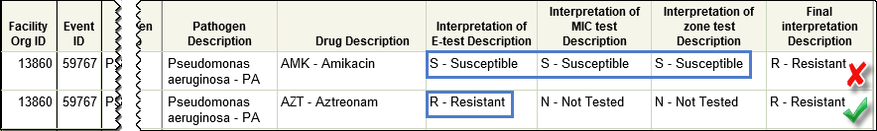
Note: You’ll need to modify the AR Event Line List to include the specific test interpretations (E-test, MIC, and Disk Diffusion [Zone test]) along with the final interpretation.

Note: When reviewing Staphylococcus aureus isolates, please also modify the Line List to include PBP2a-agglutination and PCR mec-gene variables as both variables can influence the lab’s final interpretation.

- Confirm: Review 10 AR Events with specimens:
- Collected during the last 7 days of the month
or
- With target organisms identified where subsequent susceptibility testing may have been performed

Confirm any subsequent susceptibility testing completed by the lab is included in the NHSN AR Event results. See note below.

Tip: Complete this by comparing NHSN data to final lab results in the EHR or LIS at least one week after the result was entered into the EHR or LIS.

Note: Only report final or corrected susceptibility testing to NHSN. Do not report preliminary laboratory results to NHSN. Submitters can upload AR Data to NHSN in a monthly batch submission and are not expected to be upload data in real time.

Answer the questions below using the report titled: Line Listing – Antimicrobial Resistant Organisms. Use the Analysis QRG for tips on how to make modifications.
- Confirm: Review the Antimicrobial Resistant Organisms Line List to confirm MDROs at your facility are being submitted to NHSN. For example, if your facility uses colistin, polymyxin B, newer B-lactam/Β-lactamase inhibitor (for example, ceftazidime/avibactam, ceftolozane/tazobactam) or other recently approved agents targeting MDROs, review the AR Organism Line List for carbapenem-resistant Enterobacteriaceae (CRE), carbapenem-non-susceptible Pseudomonas aeruginosa, and carbapenem-non-susceptible Acinetobacter spp.
Note: If you’ve used these drugs but you cannot find these MDROs in the NHSN AR Organism Line List, consider reviewing the LIS or laboratory results in the EHRs for these organisms for data covering at least 3 months prior to the drug administration(s). Speak with the vendor being used to submit AR Option data to NHSN if you find the MDRO in your EHRs or LIS but not in the NHSN submission.

Using the NHSN Bar Chart
Answer the question below using the report titled Bar Chart – All Antimicrobial Resistance Events. Use the Analysis QRG for tips on how to make modifications.
- Confirm: Once AR Events have been submitted for at least three months, review trends over time for specific organisms: Escherichia coli, Klebsiella pneumoniae, Staphylococcus aureus, and Enterobacter spp. Discuss any unexpected AR Event numbers with the vendor being used to submit AR Option data to NHSN.

Using the NHSN Facility-wide Antibiogram
Many of the questions below require comparison to your facility’s laboratory generated antibiogram. Obtain a copy from your facility’s lab if you do not have one.

While comparing the antibiogram produced by your lab and the antibiogram produced in NHSN, keep in mind there are a number of valid reasons the reports may not be an exact match:
- The most recent laboratory produced antibiogram may be from the prior calendar year.
- As above, is the annual facility antibiogram produced by your laboratory affected by suppression, or does the lab include all susceptibility data from all tests completed? If all data are included in the annual facility antibiogram but the NHSN antibiogram is affected by suppressed data, the two reports will not match.
- Does the lab follow the CLSI M39 guidance to include only the first specimen per patient per year in the annual antibiogram? NHSN uses the 14-day and one per month reporting rules that may cause the total number of isolates included in the NHSN antibiogram to be higher than the annual facility antibiogram.

Answer the questions below using the NHSN report titled: Facility-wide Antibiogram (Percent Susceptible).
Important notes about this report:
- NHSN’s antibiogram displays % Susceptible (S).
- The report is generated using the following formula:

$$\frac{Total isolates S}{Total isolates tested} ×100$$

- A cell showing “0” indicates of all isolates tested, no isolates were S meaning all isolates were Intermediate, Resistant or non-Susceptible to the given drug.
- The report will only populate a value if greater than or equal to 30 isolates of that organism have been tested. If less than 30 isolates have been tested, NHSN will populate “.” in that cell.
- Grey cells indicate a drug for which susceptibility information is not reported for the organism.
- The report defaults to show one table per month. Change the time period by modifying the report to select Display Options then Select Group by SpecimenDateYr (calendar year) or SpecimenDateYQ (calendar quarter).

- Compare: Review the number of isolates tested within the laboratory-produced antibiogram and the number of isolates reported as tested to NHSN for an organism for the same time period. Make note of potential differences caused by:
- Your lab following CLSI M39 guidance to only include the first specimen per patient per year (would cause NHSN antibiogram to have more isolates)
- Your lab including wound or other non-NHSN specimen types in the antibiogram (would cause lab antibiogram to have more isolates)
- Or additional variation which may require further investigation

Tip: The total number of isolates reported to NHSN per organism can be found following these steps:
- Click “Analysis” then “Reports”.
- On the Analysis Reports page, click “Antimicrobial Use and Resistance Module”, “Antimicrobial Resistance Data”, “Facility-wide Antibiogram (Percent Susceptible)” then click “Modify Report”.
- On the Modification screen, click “Display Options” then select Group by: SpecmenDateYM (display by month), SpecimenDateYQ (display by Quarter) or SpecimenDateYr (display by year).
- Once the modifications have been made, click “Export” then “Export Analysis Data Set using Modifications.” Refer to the “totalIsolatesTested” column in the output.

- Once at least 30 isolates have been reported for Escherichia coli, Staphylococcus aureus, and Pseudomonas aeruginosa, review the NHSN antibiogram report and compare with your laboratory generated antibiogram to confirm the following. Depending on the size of your facility, you may need to wait until multiple months of AR Events have been reported to NHSN.

Tip: To obtain a count of isolates reported by specimen, run the Bar Chart – All Antimicrobial Resistance Events. Use the Analysis QRG for tips on how to make modifications.

- Question: Are there any large differences in the %S for specific organism/antimicrobial combinations in the two antibiograms? Investigate those with variance to determine if either antibiogram is affected by suppression, cascading, etc. While differences are expected, speak with the vendor being used to submit AR Option data to NHSN if large discrepancies are identified in the NHSN AR Option data.

- Question: Are there any required NHSN AR Option organism/antimicrobial combinations (see Appendix F in the AUR Module Protocol) missing from your NHSN antibiogram that are present in your laboratory generated antibiogram? If yes, speak with the vendor being used to submit AR Option data to NHSN to determine the source of the error(s).

- Compare: Within an organism, review for discrepancies by comparing %S of antimicrobials within the same class with similar spectrum (example: imipenem with cilastatin and meropenem with more than 10% difference for Pseudomonas aeruginosa, ciprofloxacin and levofloxacin with more than 10% difference for Escherichia coli).

Using the Rate Table
Answer the question below using the NHSN report titled Rate Table – Antimicrobial Resistance Percentages. Use the Analysis QRG for tips on how to make modifications.

- Confirm: Use the numbers isolated, tested, and resistant reported in the Rate Table to look for unexpectedly low numbers of isolates tested for antimicrobials commonly tested for the organism. For example, review the MRSA_AR phenotype table to assess whether the number of Staphylococcus aureus isolated is roughly equal to the number tested (numTested looks for testing of oxacillin or cefoxitin only). If the majority of Staphylococcus aureus collected at your facility are tested for MRSA, then the number isolated and number tested should be close. If data appear to be missing or incorrect, speak with the vendor being used to submit AR Option data to NHSN to determine the source of the error.

Using the AR Summary Data Line List
Answer the questions below using the report titled: Line Listing – All AR Summary Data. Use the Analysis QRG for tips on how to make modifications.

- Confirm: Have AR Summary data been submitted monthly? If not, please be sure to upload your facility’s monthly AR Summary CDA files.

- Confirm: Review three months of reported patient day counts. Are patient days within the ranges specified by the equations below? If the patient day count equals zero or exceeds the maximal capacity of the facility, speak with the vendor being used to submit AR Option data to NHSN to resolve the problem.

$$Patient Days>0$$

$$Patient Days<\left(\# of inpatient beds × 31\right)+\# new admissions that month$$

- Confirm: Review three months of reported admissions. Are admissions greater than zero? If not, speak with the vendor being used to submit AR Option data to NHSN to resolve the problem.

Compare AR Summary Data with Other NHSN Summary Data
- Confirm: Review the AR Option FacWideIN patient day and admission count denominators found in the AR Summary Data line list to confirm they are similar to the FacWideIN Total Facility patient day and admission counts reported in the MDRO/CDI Module. The modules use similar definitions therefore the values are expected to be close. Values may also be slightly different if different data sources are used. If large differences are found, review the locations being included in both the AR Option and MDRO/CDI LabID FacWideIN Total Facility patient day and admission counts. If the same locations are used for both, speak with the vendor being used to submit AR Option data to NHSN to determine the source of the error.

As a reminder: A patient is counted as an admission when they arrive in an NHSN designated inpatient location regardless of patient status (for example, inpatient, observation). Further, a patient admitted to an inpatient unit is counted as an admission even if they are discharged that same calendar day. Please note, the admissions definition used in the AUR Module is different than the definition used in the NHSN MDRO/CDI Module.

Tip: If submitting data into the MDRO/CDI Module, reach out to the NHSN Facility Administrator or IP staff for help obtaining the MDRO/CDI FacWideIN denominators reported to NHSN for the months undergoing validation.

  - Confirm: If your facility is not reporting to the MDRO/CDI Module and your facility has submitted data to the AU Option, compare your AR Option patient day and admission denominators to your AU Option days present and admission denominators. AR FacWideIN patient days should be less than AU FacWideIN days present. AR FacWideIN admissions and AU FacWideIN admissions should be roughly equal depending on the locations being included in both reporting options. If errors are identified, contact the vendor being used to submit AR Option data to NHSN.

Tip: To find the AU Option FacWideIN days present and admission counts, navigate to the Antimicrobial Use Data folder then select the Line Listing – All Submitted AU data for FACWIDEIN. Refer to the Analysis QRG for tips on how to make modifications.

Important Links:
AUR Module Protocol: https://www.cdc.gov/nhsn/pdfs/pscmanual/11pscaurcurrent.pdf
AR Event Line List QRG: https://www.cdc.gov/nhsn/pdfs/ps-analysis-resources/aur/AR-QRG-LineList.pdf
AR Organism Line List QRG: https://www.cdc.gov/nhsn/pdfs/ps-analysis-resources/aur/ar-qrg-organisms-linelist-508.pdf
AR Event Bar Chart QRG: https://www.cdc.gov/nhsn/pdfs/ps-analysis-resources/aur/ar-qrg-barchart-508.pdf
AR Organism Rate Table QRG: https://www.cdc.gov/nhsn/pdfs/ps-analysis-resources/aur/ar-qrg-ratetable-508.pdf
AR Summary Data Line List QRG: https://www.cdc.gov/nhsn/pdfs/ps-analysis-resources/aur/ar-qrg-denom-linelist-508.pdf
MDRO/CDI Module Protocol: https://www.cdc.gov/nhsn/pdfs/pscmanual/12pscmdro_cdadcurrent.pdf
AU Line List QRG: https://www.cdc.gov/nhsn/pdfs/ps-analysis-resources/aur/AU-QRG-LineList.pdf

