[NISVS: Customizable Overview]
Sample Introduction Text. Everyone deserves to live a life free of violence. Unfortunately, intimate partner violence (IPV), sexual violence (SV), and stalking are some of the most serious public health problems facing the country and [state name]. Victims of violence suffer not only the immediate effects, but also long-term physical, psychological, and social consequences.
How many people are affected by IPV, SV, and stalking?
Sample Text. Estimates for IPV, SV, and stalking are alarmingly high for adult Americans. To better describe and monitor the magnitude and to help address these issues, the Centers for Disease Control and Prevention (CDC) designed the National Intimate Partner and Sexual Violence Survey (NISVS). Based on 2010 NISVS data, the findings show that, on average, 24 people per minute are victims of rape, physical violence, or stalking by an intimate partner in the United States. Over the course of a year, that equals more than 12 million women and men.

[Add narrative on overall findings specific to your state.]
 | National | [State Name]
Example: Rape Victimization (Women) | 21,840,000 | 406,000
[DATA POINT]
[DATA POINT]
[DATA POINT]
[DATA POINT]
[DATA POINT]
Why is this issue important?
Sample Text. The private nature of these public health issues makes them particularly difficult to monitor, evaluate, and address. But the need is especially acute because IPV, SV, and stalking can create a ripple effect of negative health consequences well beyond the immediate injury. We have
only begun to understand the cumulative health and social costs of these challenges; conservative estimates begin in the billions of dollars in terms of lost productivity, direct medical care, ongoing
health care, and lost earnings by IPV, SV, and stalking victims. Most importantly, these problems are preventable.
How can we prevent IPV, SV, and stalking?
Sample Text. Collective action is needed to implement prevention approaches and ensure appropriate responses.
It is important for all sectors of society, including individuals, families, and communities to work together to end IPV, SV, and stalking. Opportunities for prevention and intervention include:
- Promote healthy, respectful relationships in families by fostering health parent-child relationships and developing positive family dynamics and emotionally supportive environments.
- Provide coordinated services for survivors of IPV, SV, and stalking to ensure healing and prevent recurrence of victimization.
- Hold perpetrators responsible by enforcing laws adequately and consistently.
- Implement strong data systems for the monitoring and evaluation of IPV, SV, and stalking to help understand trends in these problems, provide information on which to base development and evaluation of prevention and intervention programs, and monitor and measure the effectiveness of these efforts.
What are we doing in [State] to prevent IPV, SV, and stalking?
[Add narrative on what initiatives and programs are happening in your state.]
Who is [Program/Organization Name]?
[Add narrative about your program or organization.] 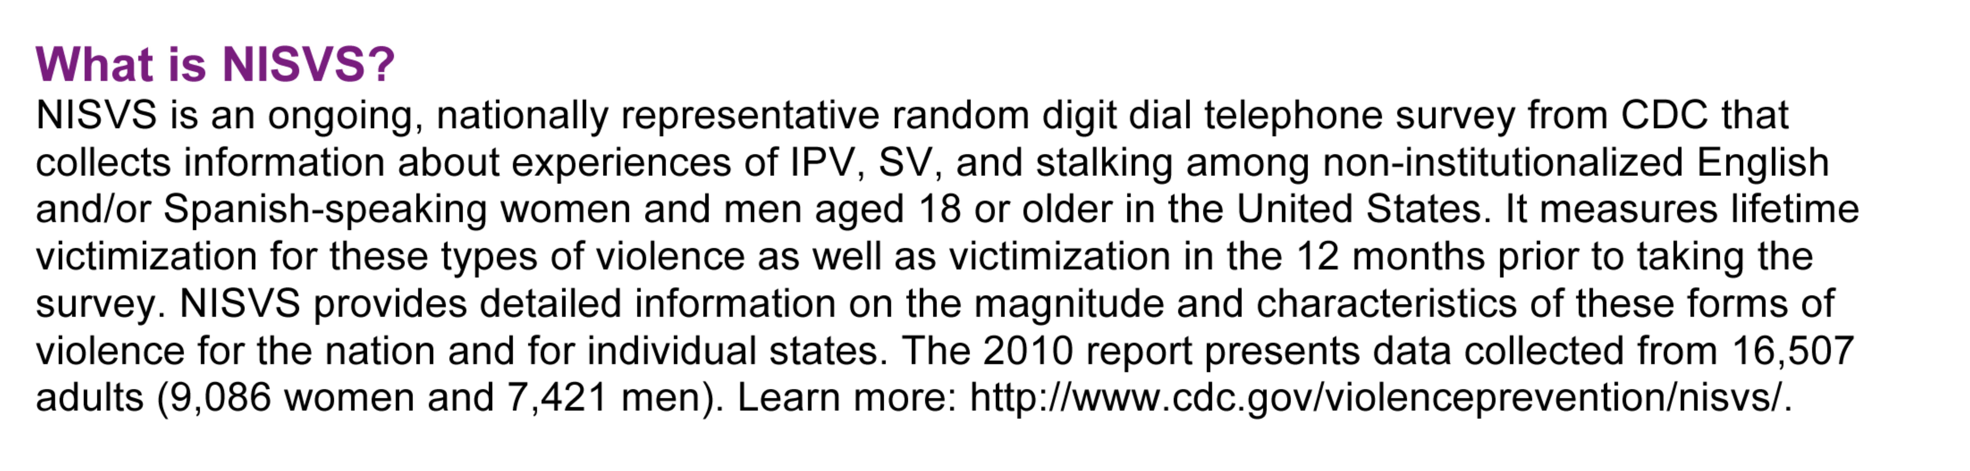
[PROGRAM LOGO]
[PROGRAM CONTACT INFORMATION]

