National Center for Emerging and Zoonotic Infectious Diseases (proposed) Tel: (404) 639-1075
Division of Viral and Rickettsial Diseases Fax: (404) 639-4436
Rickettsial Zoonoses Branch

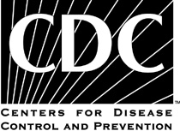

Rickettsial Swab Samples

This document has been removed. It has been replaced by Collection and Submission of Eschar Swab Specimens.

