National Center for Emerging and Zoonotic Infectious Diseases Tel: (404) 639-1075
Division of Vector-Borne Diseases Fax: (404) 639-4436
Rickettsial Zoonoses Branch

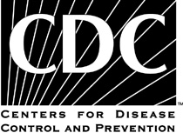 Rickettsial Skin Biopsy

This document has been removed. It has been replaced by Collection and Submission of Skin Biopsy Specimens.

