Name:

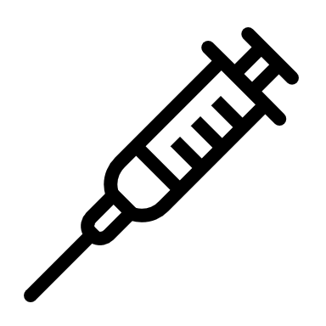 | COVID-19 Vaccination  Student Data Collection Sheet

Think About It! Write your answers below:
Understanding COVID-19 Vaccination | - How do you think vaccines prevent illness?
 | - What are some reasons that a person might get a COVID-19 vaccine?
 | - How safe and effective are vaccines against COVID-19?

COVID-19 Vaccination and CDC | - How is CDC supporting the efforts to vaccinate all Americans against COVID-19?
 | - Why is getting a COVID-19 vaccine important?
 | - How are mRNA vaccines different from most other vaccines?
In this step, you share your information. Sharing the information you collect is key. Click the links below to share:
https://observer.globe.gov/do-globe-observer/mosquito-habitats
http://www.citizenscience.us/imp/collectionform.php

Citizen Science | - Why is it important to identify vulnerable populations when administering vaccines?
 | - Who are trusted community members who help people make vaccine decisions?
 | - Why are vaccines our best defense against coronavirus?

Build a Model for Population Immunity: Data Collection

Round 1 Data
# vaccinated | 32 / 64 = % vaccinated
# unvaccinated | 32 / 64 = % unvaccinated

Trial 1 | # infected | /64 = % infected | # of unvaccinated who were not infected | / 32 = % uninfected
Trial 2 | # infected | /64 = % infected | # of unvaccinated who were not infected | / 32 = % uninfected
Trial 3 | # infected | /64 = % infected | # of unvaccinated who were not infected | / 32 = % uninfected
Average | % infected | % | % of unvaccinated who were not infected | %

Round 2 Data
# vaccinated | 48 / 64 = % vaccinated
# unvaccinated | 16 / 64 = % unvaccinated

Trial 1 | # infected | /64 = % infected | # of unvaccinated who were not infected | / 32 = % uninfected
Trial 2 | # infected | /64 = % infected | # of unvaccinated who were not infected | / 32 = % uninfected
Trial 3 | # infected | /64 = % infected | # of unvaccinated who were not infected | / 32 = % uninfected
Average | % infected | % | % of unvaccinated who were not infected | %

Based on the rules of this game, how many of the 64 people would be infected if there were no vaccinated individuals in the sample?

As the number of people who were vaccinated increased from 50% to 75%, how did the number of people infected in the outbreak change?

How did your R_{t} compare to your R₀ in each round?

How do unvaccinated individuals benefit from others in their community who are vaccinated?

Some people are unable to be vaccinated due to age, allergies, or other medical reasons. Why is population immunity so important to this group of people?

Publish Your Vaccine Story
Decide how you want to share your story. You can make a website, video, digital book, social media post, or any other format that you feel comfortable using. The key feature is to make it personal. This is not about a pandemic that affects the whole world. It’s just about you and your story.
- Tell your COVID-19 story.
How has this pandemic affected you personally? What are the mental, physical, and social effects that you have experienced firsthand?
- Describe how the vaccine has impacted you.
What does the vaccine mean to you? How has the vaccine changed things? Have your family members been vaccinated? Have you?
- Convince others to get vaccinated.
Why is it important to you that others get vaccinated? Keep it hopeful and positive!
Make notes or draw an outline of your story in the space below to help you brainstorm and prepare.

Reflections
Now that you have completed this investigation, think about what you learned from your research. Answer the questions below.
- Can getting the vaccine give you COVID-19? Explain your answer.

- Explain two safety measures that CDC and the FDA have taken to ensure vaccine safety.

- COVID-19 is a zoonotic disease, meaning it can be transmitted from non-human animals to humans. Why does that make it hard to control?

- Use the COVID Data Tracker from CDC or other data source to analyze the number of fully vaccinated individuals in your area versus the rest of the country. What do you see? How do you think your state is progressing with vaccinations?

- Use the Trends in COVID-19 Vaccine Confidence visualizer to see current trends in vaccination intent across the United States and broken down by state. What trends or patterns do you notice? What surprised you? What do you want to know more about?

- What are your personal strategies for inspiring vaccine confidence in others?

