Name:

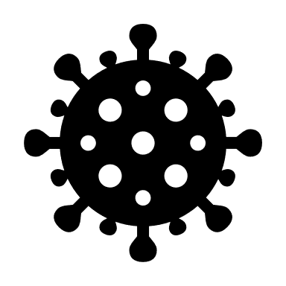 | Learning from Pandemic Flu  Student Data Collection Sheet

Think About It! Write your answers below:
Understanding Pandemic Flu | - How can a disease cause a pandemic?
 | - What groups of people do you think need to be concerned about pandemic flu?
 | - If you were the U.S. president, what would you do to prepare for pandemic flu?

Pandemic Flu and CDC | - The World Health Organization monitors which influenza viruses are currently circulating to make vaccines that protect against those specific viruses. Sometimes the vaccines are not a good match to the outbreaks. What do you think that means for the immunity of the population? How will it affect cases and deaths?
 | - In recent pandemics, the World Health Organization has opted for more generic names for diseases and infectious agents rather than the typical place-based options. Rather than calling it Spanish flu, 1918 pandemic flu is generally used. Why is this change important from a social equality perspective?
 | - How has our experience with pandemic flu helped us to prepare for the COVID-19 pandemic? Note: COVID-19 is caused by a novel coronavirus rather than a novel influenza virus but both viruses have caused epidemics and pandemics.

Citizen Science | - What are some other pandemics that occurred before the 1900’s that you’ve learned about in the past? How did they change history?
 | - Should epidemiologists consider anything other than direct health effects when responding to pandemics? For instance, if a quarantine due to disease exposure is going to cause someone to lose their job or house, should that be considered?
 | - The response to COVID-19 in the United States was slow at first, due to political divisions. Do you think that pandemics are always inherently political? Why or why not?

Stop a Flu Pandemic – The Public Health Approach
- Risk Factor Identification: What is the cause?
If you were Wilmer Krusen, what concerns would you have about the parade?

- Intervention Evaluation: What works?
Based on what you know about how influenza is transmitted from person to person and the background information provided about Philadelphia, describe a few interventions that will help prevent the flu from spreading.

- Implementation: How would you do it?
From Krusen’s perspective, what are the pros and cons of having the parade?
PROS: | CONS:

Prevent a Pandemic – The Public Health Approach
- Risk Factor Identification: What is the cause?
In this outbreak, person-to-person transmission of disease does not appear to be a major concern. With that in mind, what should be your focus areas when designing H5N1 flu interventions?

This outbreak occurred right at the beginning of the normal flu season, so H1N1 and H3N2 flu viruses were already circulating in the population. Why were health officials especially concerned by the emergence of H5N1 flu in humans at the same time as other flu types?

- Intervention Evaluation: What works?
What is causing these infections?

What are three possible things you could do to stop the infections from occurring or spreading? When designing your interventions, be sure to consider social, political, cultural, and economic factors that might impact the effectiveness of your intervention.

- Implementation: How would you do it?
Describe the intervention you are choosing to implement. Make sure to consider whether this is a long-term or short-term intervention.

What resources will you need to make this happen?

What barriers might make it difficult for you to implement your intervention?

Reflections
Now that you have completed this investigation, think about what you learned from your research. Answer the questions below.
- When does an outbreak or epidemic become a pandemic?

- What makes seasonal flu different from pandemic flu?

- What are some reasons why pandemic preparation is less expensive than response is?

- In the United States, the death toll from COVID-19 has exceeded that of the 1918 pandemic flu. Aside from a population that has more than tripled since 1918, what other social or biological factors might explain the high death toll?

- Significant efforts were made to get samples of the 1918 H1N1 pandemic flu virus decades after it ended, including exhuming frozen bodies in rural Alaska. Why do you think scientists wanted these viral samples so badly? (click here for more info if you’re interested)

- In November 2020, disease surveillance in Denmark detected a coronavirus that was widespread in minks. The virus originated in humans, transferred to minks from the handlers, mutated, and could be spread back to humans. Denmark ordered all 17 million minks killed and locked down the entire region. Was this the right decision? Why or why not?

