Name:

Investigating Influenza
Student Data Collection Sheet

Think About It! Write your answers below:
Understanding Influenza | - Do you or any of your family members get a yearly flu vaccine? Why or why not?
 | - Have you ever had the flu? How did it feel? Note: The “stomach flu” isn’t a flu! It’s a type of unrelated gastrointestinal illness.
 | - Do you think having the flu is a big deal? Why or why not?

Influenza  and CDC | - Why is antigenic shift potentially much more dangerous than antigenic drift?
 | - Novel influenza viruses (viruses different from those currently in circulation) must be reported immediately to CDC. Why do you think this requirement exists?
 | - Use HHMI’s Virus Explorer to examine the characteristics of common viruses. What do you notice about the sizes, shapes, and structures of the viruses shown? https://media.hhmi.org/biointeractive/click/virus-explorer
In this step, you share your information. Sharing the information you collect is key. Click the links below to share:
https://observer.globe.gov/do-globe-observer/mosquito-habitats
http://www.citizenscience.us/imp/collectionform.php

Citizen Science | - Many flu-related deaths occur because of secondary pneumonia infections that occur in weakened or damaged lungs. How can vaccines help prevent this?
 | - A high dose vaccine containing 4 times the flu virus antigen is generally given to adults 65 and older. What effect do you think this has on the immune system? Why is this recommended for older adults?
 | - Do you think you should wear a mask when sick to prevent spreading flu? Explain.

Investigate Common Myths Around Influenza

Brainstorm - Common Myths About the Flu
What myths, sayings, or old wives’ tales have you heard about the flu? Here are some examples to get you started:
- Feed a fever; starve a cold.
- If you’re outside in the cold for too long, you’ll get sick.
- Don’t drink milk if you’re sick.
- A flu shot can give you the flu.

How do you feel about these? Is there any truth to any of these wives’ tales? Why do they persist?

Design an Experiment
Which of your flu myths will you investigate?

What are the variables in your experiment?
Independent (manipulated)
Dependent (responding)
Controls

Use this template to design your experiment.
Ask a Question
What myth do you want to investigate? Pose an investigative question.
Do Background Research
What information would you need to research to understand the topic better?
Construct a Hypothesis
What will you be testing? An easy hypothesis format is
“If ______, then ______.”
Test with an Experiment
How would you design an experiment that would test this hypothesis? How many people? Where? What exactly will you do? What are your control and experimental groups? Be as specific as possible here.
Analyze Data
How would you analyze the data collected in the experiment to look for patterns? What would you expect to see?
Draw Conclusions  What story does your data tell? Go back to your hypothesis and either accept or reject it. | Since you’re not actually conducting this experiment or collecting data, you won’t be able to analyze anything here. You can take a second and think about what different results would mean though! Plus, you’ll be analyzing data in the next activity.
Communicate Results  Summarize your findings so that others may benefit from your knowledge or independently verify your results (peer review). | You won’t really be able to communicate the results for an experiment you haven’t conducted, but it is good to think about how researchers use scientific publications to present their findings to others in the field. Publishing your research is a really big deal in science and requires a wide variety of high-level skills to accomplish!

Analyze Influenza Data
CDC tracks instances of about 120 diseases through the National Notifiable Disease Surveillance System, including infectious diseases, bioterrorism agents, sexually transmitted diseases, and noninfectious conditions. About 3,000 local public health departments send disease data to 60 state, territorial, and other public health departments, who then send the data to CDC.

What story does the data tell?
If you collected the data below during routine disease surveillance, what would you do with them? The three graphs below are some examples of data CDC collects. Using the data to make recommendations to health officials and the general public is one of CDC’s most important duties.
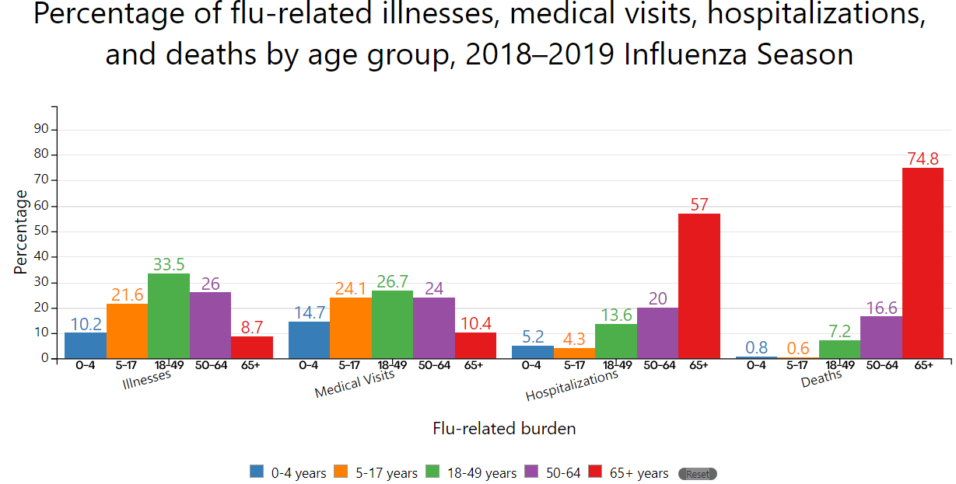
Examine the x-axis, y-axis, graph title, units, and color key. What are some things you notice about this graph?

What health recommendations would you make based on the information presented above?

A single graph cannot tell the full story of a disease outbreak. What questions do you have after looking at the data above? What do you want to know more about?

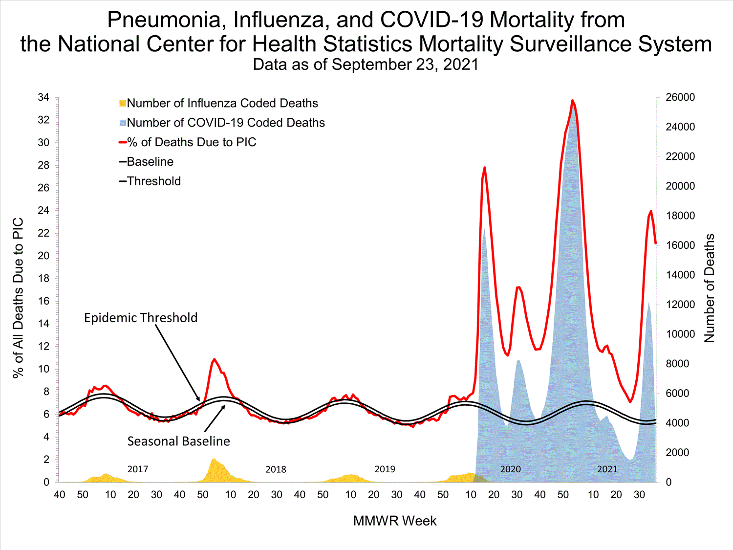

Analyzing a Graph: What Do These Terms Mean?
■ Number of Influenza Coded Deaths | Number of deaths that listed influenza as underlying or contributing cause of death (use right axis for numbers)
■ Number of COVID-19 Coded Deaths | Number of deaths that listed COVID-19 as underlying or contributing cause of death (use right axis for numbers)
— % Deaths Due to PIC | Percentage of all deaths that listed PIC (pneumonia, influenza, or COVID-19) as underlying or contributing cause of death (use left axis for numbers)
— Baseline  — Threshold | Baseline number is calculated using statistics from previous flu seasons; an increase of 1.645 standard deviations above the seasonal baseline is considered the epidemic threshold, indicating viral spread that is far above expected values
MMWR Week | Weeks of the year are numbered 1-53 based on MMWR number; ensures consistent and timely reporting of cases by local and state health departments
Flu season is reported from MMWR week 40 of one year to week 39 of the next (labeled on the x-axis). You can make this easier to visualize by drawing a vertical line at each 40 on the x-axis to separate the seasons from each other.

How would you describe each of these flu seasons based on the information in the graph above?
2016-17
2017-18
2018-19
2019-20
2020-21

You often hear people dismiss COVID-19’s severity by describing it as “just a flu.” Although both illnesses affect the lungs and share some common symptoms, the two illnesses are unrelated. The influenza virus causes the flu while the SARS-CoV-2 virus causes COVID-19. Let’s ignore the differences and just compare the numbers.

Looking at the data from 2016-2021, how do the numbers of deaths from influenza compare to the deaths from COVID-19?

Based on what you know about flu, why should people take it seriously?

The graph below shows the 10 leading causes of death in 2019, which account for 73.4% of all deaths. What does this tell you about the flu? Is this surprising to you? Explain your answer.
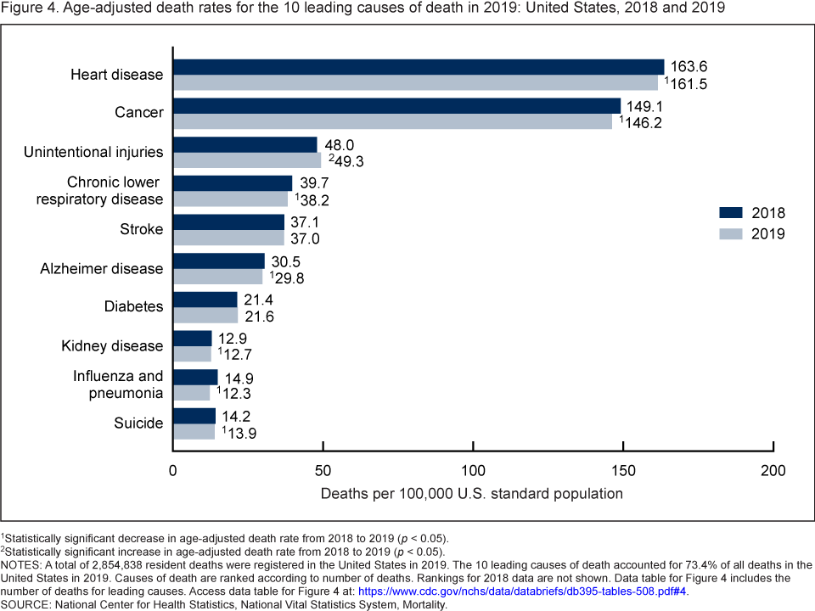

Reflections
Now that you have completed this investigation, think about what you learned from your research. Answer the questions below.
- Who is most at risk for hospitalization or death from influenza? What are some ways they can they protect themselves from getting the flu?

- What are some similarities and differences between H3N2 and H2N2 viruses?

- A researcher is conducting a single-blind vaccination trial. What are some ways that the researcher might accidentally introduce bias because they know who will get placebos?

- Free flu vaccines are widely available to people in the United States. Why do you think health insurance companies and other organizations are willing to fund these shots?

- A healthy 30-year-old man tells you he doesn’t need a flu shot. How do you convince him?

- After the success of the new mRNA vaccines for COVID-19, research is underway to produce mRNA vaccines for influenza that use the sequences for influenza surface proteins. What challenges might be involved with this process?

