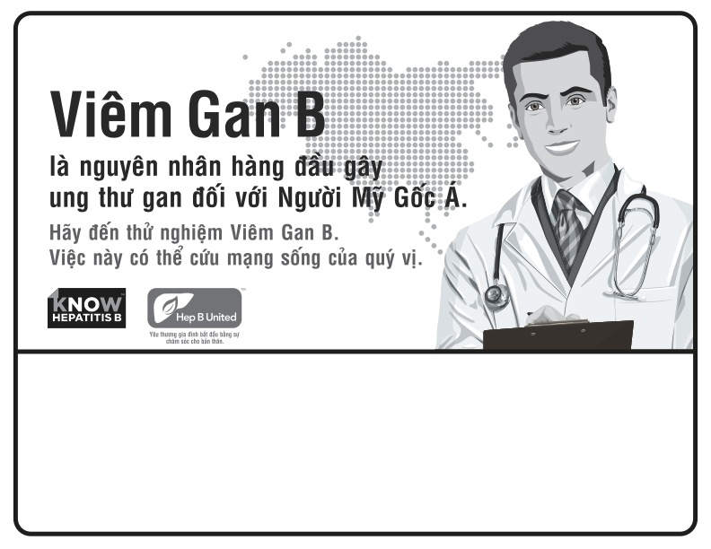

Sunday, May 19, 2014 | 10AM – 3PM

Sponsoring Organization Name

100 Main Street, | City, State

Call (000) 999-9999 for more information