Mississippi Fruit and Vegetable Pilot
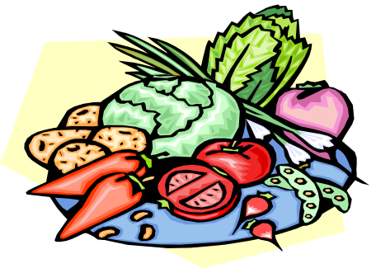

Student Survey – 8th & 10th grades

Please make any corrections to your name and grade. Then fill in today’s date and your birth date in the box below. This information will be kept private. Please print neatly. When you are done with this page, please tear it off and we will collect it from you. Thank you!

Today’s Date: _______ / _______ / _______ __
(Month) (Day) (Year)

Your Birth Date: _______ / ______ / _19______
(Month) (Day) (Year)

Note that the 5th grade version of this survey did not include food frequency questions (questions 56-97). In addition, questions 106-118 were included only at posttest; the 5th grade posttest survey did not include questions 113-116.

==============================================================================================
This evaluation tool was developed by the Mississippi Department of Education with technical assistance from the Division of Adolescent and School Health of the U.S. Centers for Disease Control and Prevention. Its contents are solely the responsibility of the authors and do not necessarily represent the official position of the Centers for Disease Control and Prevention.
==============================================================================================

Mississippi Fruit and Vegetable Pilot

Student Survey

8th & 10th grades

- This survey is voluntary. This means it is up to you whether or not you complete this survey. You do not have to finish it, but we hope that you will.

- This survey asks about you and what you think about eating different foods.

- Your answers will help schools find better ways to help students be healthy.

- No one but you will know how you answer these questions.

- Please read each question carefully.

- Use a ✓or an X to mark the answer that is best for you.

- Please mark only 1 answer for each question unless there are other directions.

- Raise your hand to ask for help if you have questions.

Thank you for taking this survey!
Instructions: Please read each question carefully. Use a ✓ or an X to mark the best answer that shows how you feel.

Questions about you…

1. Are you:

₁ Male (boy) OR ₂ Female (girl)

2. What grade are you in now?

₁ 4th grade ₅ 8th grade
₂ 5th grade ₆ 9th grade
₃ 6th grade ₇ 10th grade
₄ 7th grade ₈ 11th grade

3. How old are you now?

₁ 9 years old or younger ₆ 14 years old
₂ 10 years old ₇ 15 years old
₃ 11 years old ₈ 16 years old
₄ 12 years old ₉ 17 years old or older
₅ 13 years old

4. Which race or ethnicity describes you? Mark all answers that describe you

the best.

I am…

₁ Black or African American
₂ Hispanic or Latino/Latina
₃ American Indian
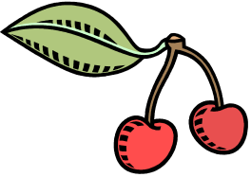
₄ Asian American or Pacific Islander
₅ White
₆ Other (please describe) ____________________________

The next questions ask about different foods you would eat. Mark one answer for each question.

5. Would you eat fruit for snacks if  they were served to you at home or  school? | I never would  ₁□ | I rarely would  ₂□ | I would sometimes  ₃□ | I would most of the time  ₄□
6. Would you choose fruit as a snack  instead of chips or candy? | I never would  ₁□ | I rarely would  ₂□ | I would sometimes  ₃□ | I would most of the time  ₄□
7. Would you eat vegetables for  snacks if they were served to you  at home or school? | I never would  ₁□ | I rarely would  ₂□ | I would sometimes  ₃□ | I would most of the time  ₄□
8. Would you choose vegetables as a  snack instead of chips or candy? | I never would  ₁□ | I rarely would  ₂□ | I would sometimes  ₃□ | I would most of the time  ₄□

Please check the box that most closely describes how much you agree or disagree with each statement. There are no wrong answers.

9. I am sure I can eat a fruit that is  served at school. | Disagree a lot  ₁□ | Disagree a little  ₂□ | Not sure  ₃□ | Agree a little  ₄□ | Agree a lot  ₅□
10. I am sure I can eat a vegetable that  is served at school. | Disagree a lot  ₁□ | Disagree a little  ₂□ | Not sure  ₃□ | Agree a little  ₄□ | Agree a lot  ₅□
11. I am sure I can eat more fruit every  day than I am eating now. | Disagree a lot  ₁□ | Disagree a little  ₂□ | Not sure  ₃□ | Agree a little  ₄□ | Agree a lot  ₅□
12. I am sure I can eat more vegetables  every day than I am eating now. | Disagree a lot  ₁□ | Disagree a little  ₂□ | Not sure  ₃□ | Agree a little  ₄□ | Agree a lot  ₅□

Questions 13-21 were from an Outcome Expectations scale created by Baranowski, Davis, Resnicow, et al., 2000.
What kinds of fruit and vegetables have you tried?
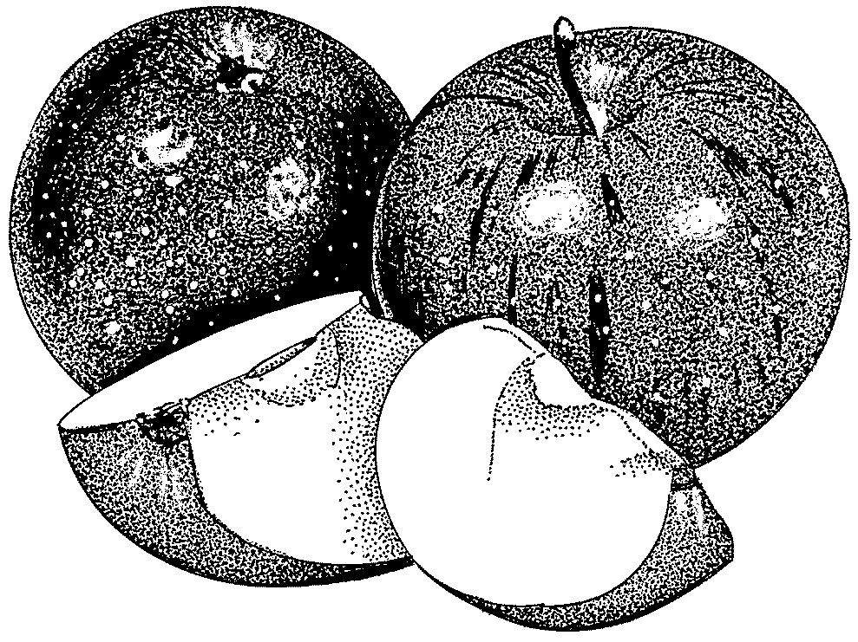
22a. Have you ever eaten an apple?
₁ Yes
₂ No
b. How much do you like or think you would like apples?
₁ A lot
₂ A little
₃ Not at all

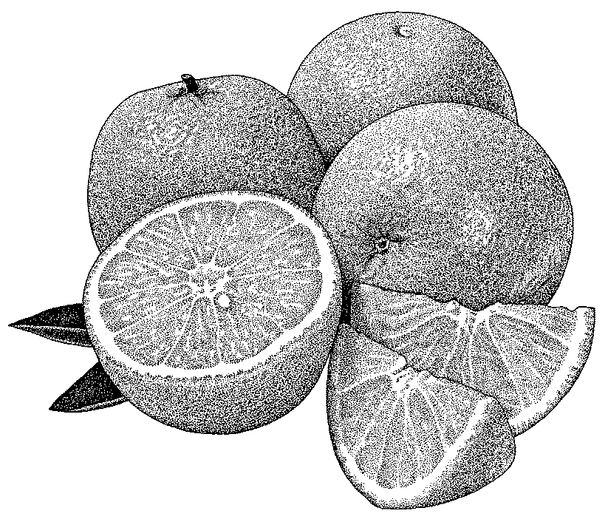

23a. Have you ever eaten an orange?
₁ Yes
₂ No
b. How much do you like or think you would like oranges?
₁ A lot
₂ A little
₃ Not at all

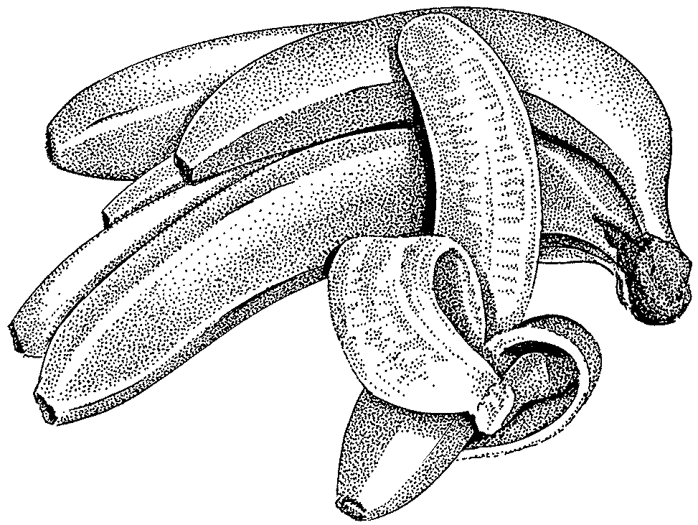
24a. Have you ever eaten a banana?
₁ Yes
₂ No
b. How much do you like or think you would like bananas?
₁ A lot
₂ A little
₃ Not at all

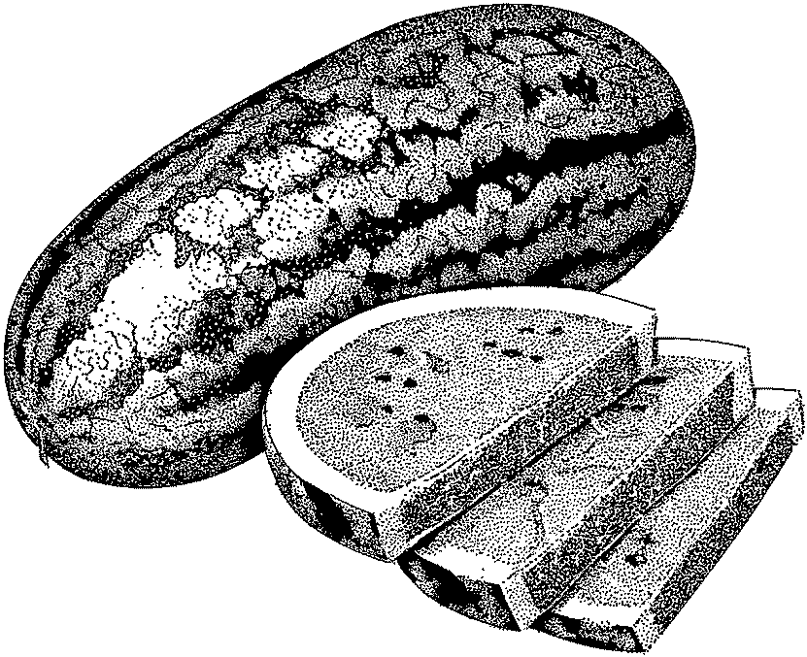
25a. Have you ever eaten watermelon?
₁ Yes
₂ No
b. How much do you like or think you would like watermelon?
₁ A lot
₂ A little
₃ Not at all
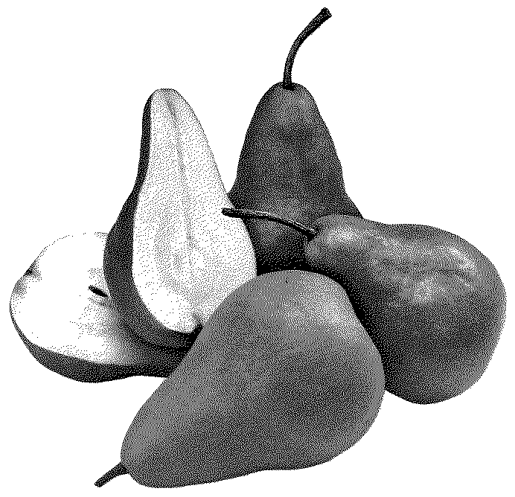
26a. Have you ever eaten a pear?
₁ Yes
₂ No
b. How much do you like or think you would like pears?
₁ A lot
₂ A little
₃ Not at all
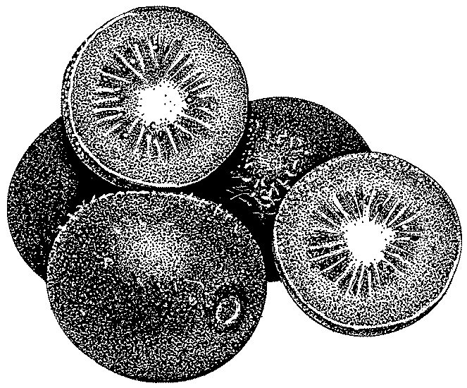
27a. Have you ever eaten a kiwi?
₁ Yes
₂ No
b. How much do you like or think you would like kiwis?
₁ A lot
₂ A little
₃ Not at all

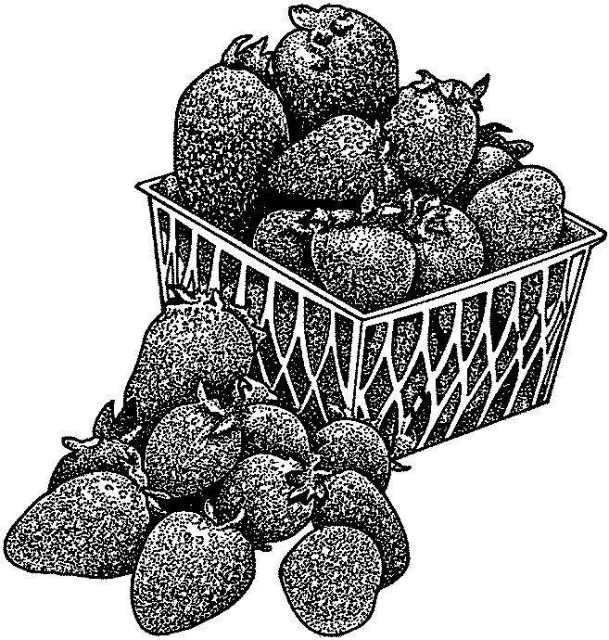
28a. Have you ever eaten a strawberry?
₁ Yes
₂ No
b. How much do you like or think you would like strawberries?
₁ A lot
₂ A little
₃ Not at all
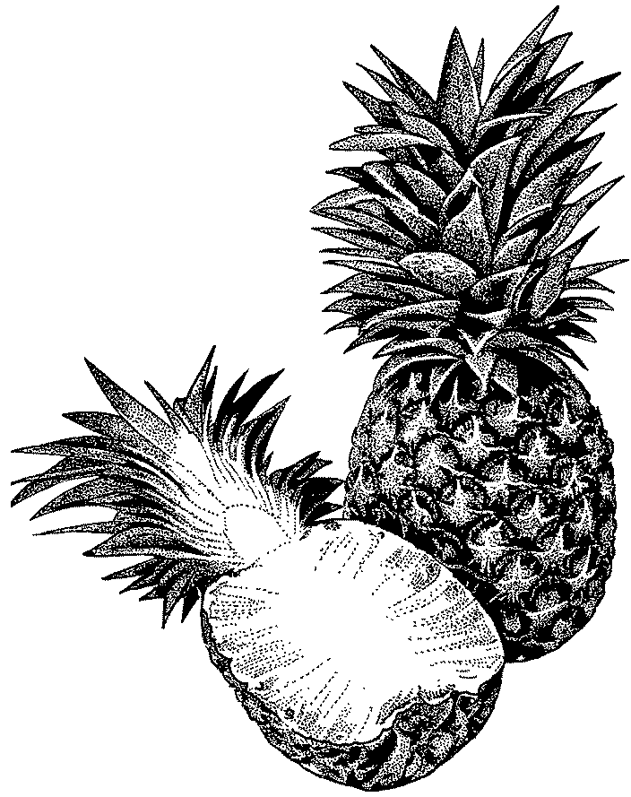

29a. Have you ever eaten pineapple?
₁ Yes
₂ No
b. How much do you like or think you would like pineapple?
₁ A lot
₂ A little
₃ Not at all

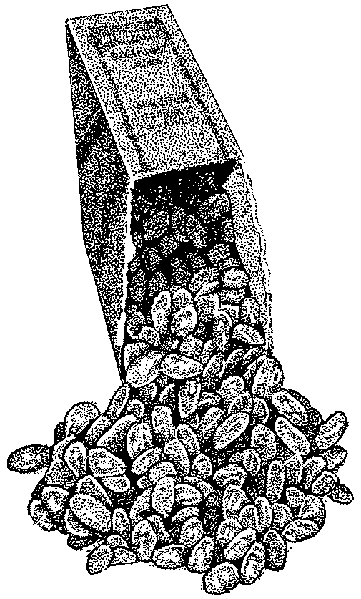
30a. Have you ever eaten raisins?
₁ Yes
₂ No
b. How much do you like or think you would like raisins?
₁ A lot
₂ A little
₃ Not at all

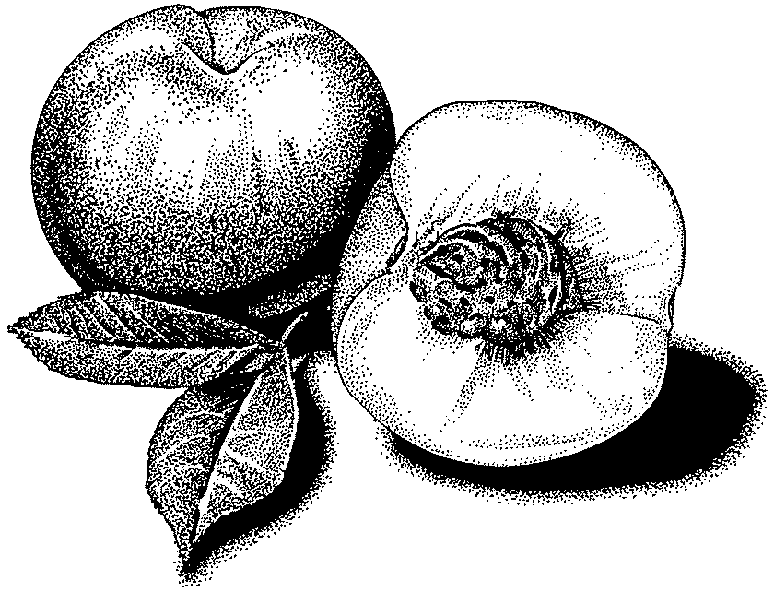
31a. Have you ever eaten a peach?
₁ Yes
₂ No
b. How much do you like or think you would like peaches?
₁ A lot
₂ A little
₃ Not at all

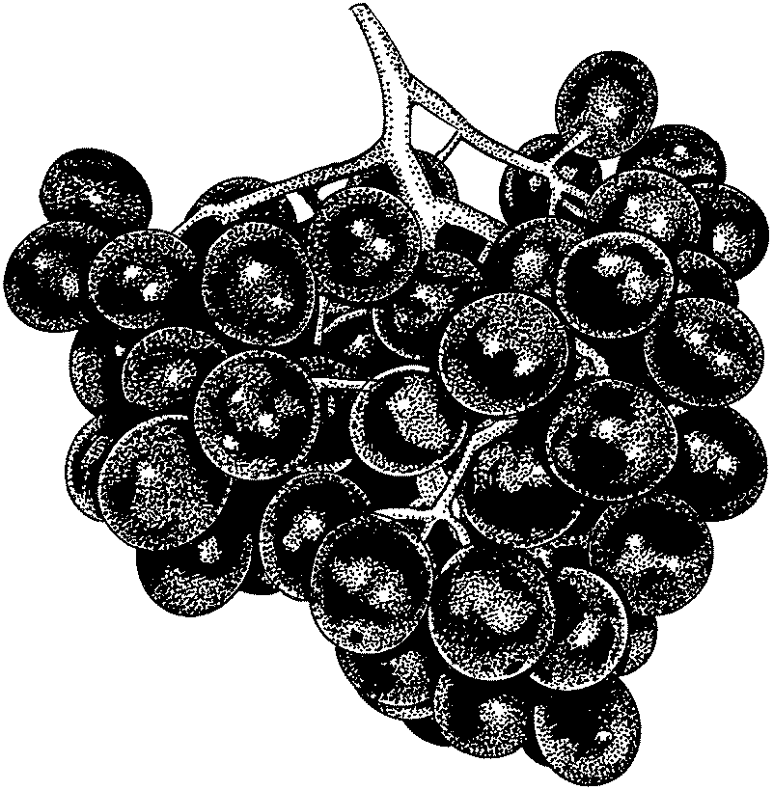
32a. Have you ever eaten grapes?
₁ Yes
₂ No
b. How much do you like or think you would like grapes?
₁ A lot
₂ A little
₃ Not at all

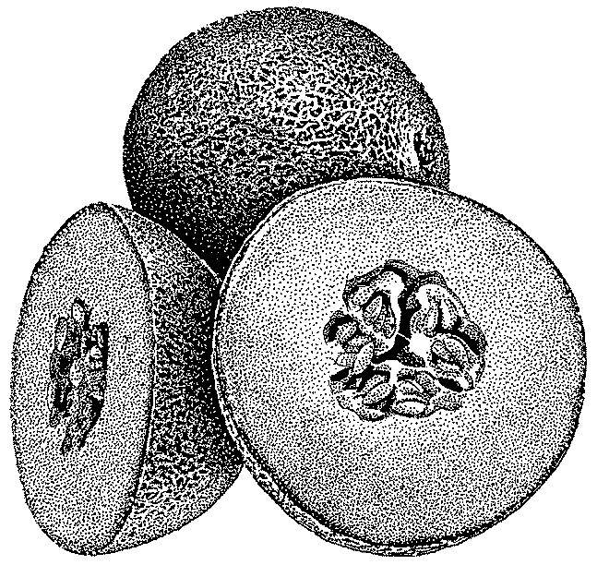
33a. Have you ever eaten cantaloupe?
₁ Yes
₂ No
b. How much do you like or think you would like cantaloupe?
₁ A lot
₂ A little
₃ Not at all


34a. Have you ever eaten honeydew melon?
₁ Yes
₂ No
b. How much do you like or think you would like honeydew melon?
₁ A lot
₂ A little
₃ Not at all

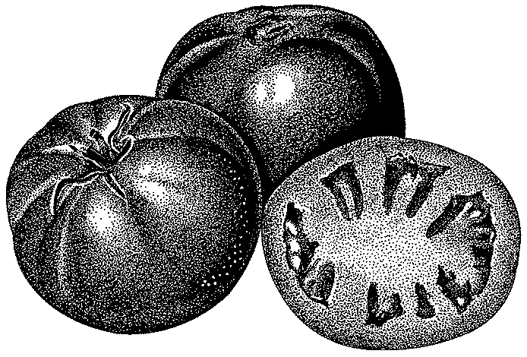
35a. Have you ever eaten a tomato?
₁ Yes
₂ No
b. How much do you like or think you would like tomatoes?
₁ A lot
₂ A little
₃ Not at all

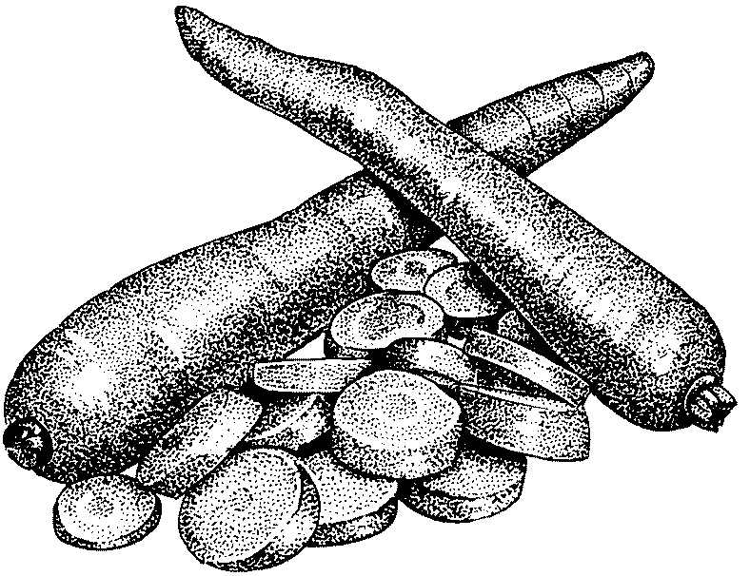
36a. Have you ever eaten a raw carrot?
₁ Yes
₂ No
b. How much do you like or think you would like raw carrots?
₁ A lot
₂ A little
₃ Not at all

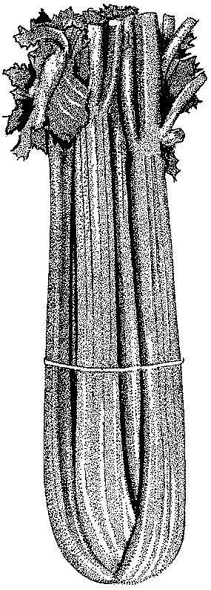
37a. Have you ever eaten celery?
₁ Yes
₂ No
b. How much do you like or think you would like celery?
₁ A lot
₂ A little
₃ Not at all


38a. Have you ever eaten raw broccoli?
₁ Yes
₂ No
b. How much do you like or think you would like raw broccoli?
₁ A lot
₂ A little
₃ Not at all


39a. Have you ever eaten raw cauliflower?
₁ Yes
₂ No
b. How much do you like or think you would like raw cauliflower?
₁ A lot
₂ A little
₃ Not at all

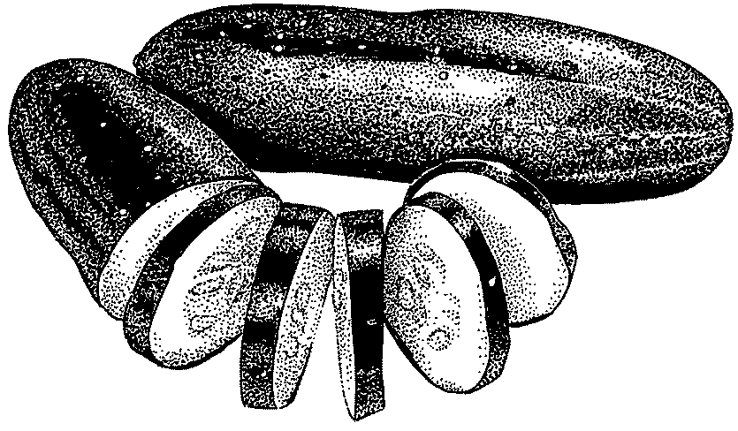
40a. Have you ever eaten cucumber?
₁ Yes
₂ No
b. How much do you like or think you would like cucumber?
₁ A lot
₂ A little
₃ Not at all

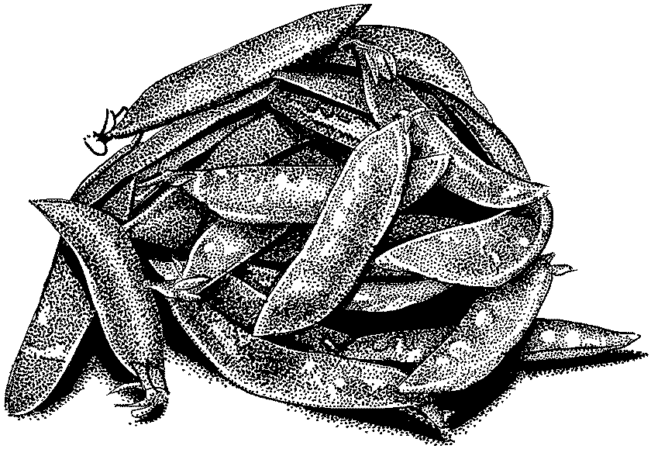
41a. Have you ever eaten sugar snap peas?
₁ Yes
₂ No
b. How much do you like or think you would like sugar snap peas?
₁ A lot
₂ A little
₃ Not at all

How would you feel about these things?
42. If a new kind of fruit was served with  lunch, how would you feel about  eating it? | Dislike very much  ₁□ | Dislike a little  ₂□ | In between  ₃□ | Like a little  ₄□ | Like very much  ₅□
43. If you were given a new kind of fruit  for a snack at school, how would you  feel about eating it? | Dislike very much  ₁□ | Dislike a little  ₂□ | In between  ₃□ | Like a little  ₄□ | Like very much  ₅□
44. If a new kind of fruit was served with  supper, how would you feel about  eating it? | Dislike very much  ₁□ | Dislike a little  ₂□ | In between  ₃□ | Like a little  ₄□ | Like very much  ₅□
45. If a new kind of vegetable was  served with lunch, how would you  feel about eating it? | Dislike very much  ₁□ | Dislike a little  ₂□ | In between  ₃□ | Like a little  ₄□ | Like very much  ₅□
46. If you were given a new kind of  vegetable for a snack at school, how  would you feel about eating it? | Dislike very much  ₁□ | Dislike a little  ₂□ | In between  ₃□ | Like a little  ₄□ | Like very much  ₅□
47. If a new kind of vegetable was  served with supper, how would you  feel about eating it? | Dislike very much  ₁□ | Dislike a little  ₂□ | In between  ₃□ | Like a little  ₄□ | Like very much  ₅□



How true are these for you?
48. I always try new and different fruit. | Really  not true  ₁□ | Kind of  not true  ₂□ | Kind of true  ₃□ | Really true  ₄□
49. I am afraid to eat fruit I have never had  before. | Really  not true  ₁□ | Kind of  not true  ₂□ | Kind of true  ₃□ | Really true  ₄□
50. I am very picky about the fruit I eat. | Really  not true  ₁□ | Kind of  not true  ₂□ | Kind of true  ₃□ | Really true  ₄□
51. I will eat almost any fruit. | Really  not true  ₁□ | Kind of  not true  ₂□ | Kind of true  ₃□ | Really true  ₄□
52. I always try new and different vegetables. | Really  not true  ₁□ | Kind of  not true  ₂□ | Kind of true  ₃□ | Really true  ₄□
53. I am afraid to eat a vegetable I have never  had before. | Really  not true  ₁□ | Kind of  not true  ₂□ | Kind of true  ₃□ | Really true  ₄□
54. I am very picky about the vegetables I will  eat. | Really  not true  ₁□ | Kind of  not true  ₂□ | Kind of true  ₃□ | Really true  ₄□
55. I will eat almost any vegetable. | Really  not true  ₁□ | Kind of  not true  ₂□ | Kind of true  ₃□ | Really true  ₄□
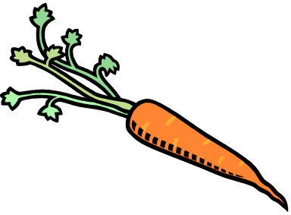

Questions 56-97 were from a fruit and vegetable frequency questionnaire created by Cullen, Baranowski, Baranowski, et al., 1999

What do you think?

98. Do your parents or guardian(s) eat fruit and vegetables every day?

₁ Never or hardly ever
₂ Sometimes
₃ Often
₄ Usually or always

99. Do your friends eat fruit and vegetables every day?

₁ Never or hardly ever
₂ Sometimes
₃ Often
₄ Usually or always

- How often do you usually eat school breakfast during a school week?

₁ Never
₂ 1-2 days a week
₃ 3-4 days a week
₄ Everyday

- When you eat the school breakfast, how often do you eat the fruit offered?

₁ I never eat the school breakfast
₂ Never
₃ Rarely
₄ Sometimes
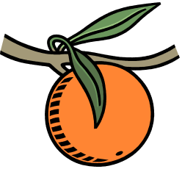
₅ Most or all of the time

- When you eat the school breakfast, how often do you eat the vegetable offered?

₁ I never eat the school breakfast
₂ Never
₃ Rarely
₄ Sometimes
₅ Most or all of the time

- How often do you usually eat school lunch during a school week?

₁ Never
₂ 1-2 days a week
₃ 3-4 days a week
₄ Everyday

- When you eat the school lunch, how often do you eat the fruit offered?

₁ I never eat the school lunch
₂ Never
₃ Rarely
₄ Sometimes
₅ Most or all of the time

- When you eat the school lunch, how often do you eat the vegetable offered?

₁ I never eat the school lunch
₂ Never
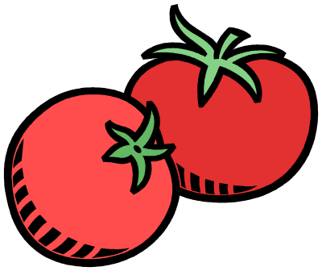
₃ Rarely
₄ Sometimes
₅ Most or all of the time

POSTTEST ONLY QUESTIONS (q106-q118)

The next questions ask about the fruit and vegetable program at your school. As part of this program, your school gave out free fruit and vegetable snacks.

106. How often did you eat the fruit snacks that were offered at your school this year?

₁ Never
₂ Rarely
₃ Sometimes
₄ Most or all of the time

107. How often did you eat the vegetable snacks that were offered at your school this year?

₁ Never
₂ Rarely
₃ Sometimes
₄ Most or all of the time

108. Did you try any new fruit from the fruit and vegetable snack program that you had never tried before?

₁ I never ate the fruit snacks at school
₂ No, none of the fruit I ate was new to me
₃ Yes, I tried 1 or 2 new fruits
₄ Yes, I tried 3 or 4 new fruits
₅ Yes, I tried 5 or more new fruits

109. Did you try any new vegetables from the fruit and vegetable snack program that you had never tried before?

₁ I never ate the vegetable snacks at school
₂ No, none of the vegetables I ate was new to me
₃ Yes, I tried 1 or 2 new vegetables
₄ Yes, I tried 3 or 4 new vegetables
₅ Yes, I tried 5 or more new vegetables

110. On most days, do you think you are eating the same amount, less, or more fruit because of your school’s fruit and vegetable snack program?

₁ I’m eating about the same amount of fruit as before
₂ I’m eating less than before
₃ I’m eating more than before

111. On most days, do you think you are eating the same amount, less, or more vegetables because of your school’s fruit and vegetable snack program?

₁ I’m eating about the same amount of vegetables as before
₂ I’m eating less than before
₃ I’m eating more than before

112. Overall, what did you think of having fruit and vegetable snacks at your school this year?

₁ Disliked it very much
₂ Disliked it a little
₃ In between
₄ Liked it a little
₅ Liked it very much



What did you think of the following parts of the fruit and vegetable snack program?
113. The variety of fruit and vegetables  served | Poor  ₁ | Fair  ₂ | Good  ₃ | Excellent  ₄
114. The quality (look and taste) of the  fruit and vegetables that were served | Poor  ₁ | Fair  ₂ | Good  ₃ | Excellent  ₄
115. The time of day the fruit and  vegetables were served | Poor  ₁ | Fair  ₂ | Good  ₃ | Excellent  ₄
116. The place where the fruit and  vegetables were served | Poor  ₁ | Fair  ₂ | Good  ₃ | Excellent  ₄

117. What did you like best about having fresh fruit and vegetable snacks at school this year?

118. What could be changed to make the fruit and vegetable program better?



Thank you for completing this survey

Instrument sources

All questions not listed in the table below were developed specifically for this project.

Questions | Construct | Source | Modifications Made
5-8 | Intentions | Buzby, J.C., Guthrie, J.F., & Kantor, L.S. (2003). Evaluation of the USDA fruit and vegetable pilot program: Report to Congress. Washington, DC: Food Assistance and Nutrition Research Program, Food and Rural Economics Division, Economic Research Service, US Department of Agriculture. | 1. Created two question from each to refer to fruit and vegetables separately.  2. Specified “served to you at home or school” based on student feedback during pilot.  3. Expanded response options from Yes/No to 4-point Likert.  Note: The “Would you…” format was specifically chosen for this survey as a measure of intention.
9-12 | Self-efficacy | Resnicow, K, Davis-Hearn, M, Smith, M, Baranowski, T, Lin, LS, Baranowski, J, Doyle, C, Wang, DT (1997). Social-cognitive predictors of fruit and vegetable intake in children. Health Psychology, 16 (3), 272-276. | 1. Changed location referent in question to “served at school” instead of “served at lunch” because MFVP produce distribution takes place at times other than lunch.  2. Q11 and Q12 created and added.
13-21 | Outcome expectations | Baranowski T, Davis M, Resnicow K, Baranowski J, Doyle C, Lin LS, Smith M, Wang DT. (2000) Gimme 5 fruit, juice, and vegetables for fun and health: outcome evaluation. Health Education Behavior, 27(1), 96-111. | 1. Question order changed to disperse negatively phrased questions.  2. Removed “I” from response options.  3. Q20 was created and added.
22-41 | Fruit and vegetable exposure preferences | Domel S., Baranowski T., Davis H., Leonard S., Riley P. & Baranowski J. (1993) Measuring fruit and vegetable preferences among 4th- and 5th-grade students. Preventive Medicine, 22, 866-879. | 1. Added a picture of the item.  2. Added the term “raw” to some vegetable items based on student feedback at pilot.  3. Only “raw” items were included in order to reflect MFVP distribution items.  Note: The list of items was based on input from the Mississippi Department of Education and student feedback on the pilot survey.
48-55 | Willingness to try new foods | Pliner, P, Hobden, K. (1992). Development of a Scale to Measure the Trait of Food Neophobia in Humans. Appetite, 19, 105-120. | 1. “Particular” changed to “picky” for Q50 and Q54 to lower reading level.  2. Created two question from each to refer to fruit and vegetables separately.  3. Reduced response options from 7 to 4 options.  4. Q48 was created and added.
56-97 | Fruit and vegetable food frequency scale | Cullen K., Baranowski T., Baranowski J., Hebert D. & de Moor C. (1999) Pilot study of the validity and reliability of brief fruit, juice and vegetable screeners among inner city African-American boys 17 to 20 year old adults. Journal of the American College of Nutrition, 18 (5), 442-450. | 1. Added new produce items based on the Jackson Heart Study: Food Frequency Questionnaire, input from Mississippi Department of Education and student feedback on the pilot survey.
98-99 | Parent/peer fruit and vegetable eating behavior | WestEd (2002). California Healthy Kids Survey: Elementary School Questionnaire 2003 (Module Supplement S, Version E1- Fall 2003). Sacramento: California State Department of Education. | 1. Removed “lots” and transformed a statement into a question.  2. Modified the peer question to have the same format as the parent question.

Portions of this instrument were adapted from the work of the following authors:

Baranowski, T., Davis, M., Resnicow, K., Baranowski, J., Doyle, C., Lin, L. S., Smith, M., & Wang, D. T. (2000). Gimme 5 fruit, juice, and vegetables for fun and health: outcome evaluation. Health Education Behavior, 27(1), 96-111.

Buzby, J. C., Guthrie, J. F., & Kantor, L. S. (2003). Evaluation of the USDA fruit and vegetable pilot program: Report to Congress. Washington, DC: Food Assistance and Nutrition Research Program, Food and Rural Economics Division, Economic Research Service, US Department of Agriculture.

Cullen, K., Baranowski, T., Baranowski, J., Hebert, D., & de Moor, C. (1999). Pilot study of the validity and reliability of brief fruit, juice and vegetable screeners among inner city African-American boys 17 to 20 year old adults. Journal of the American College of Nutrition, 18(5), 442-450).

Domel, S., Baranowski, T., Davis, H., Leonard, S., Riley, P., & Baranowski, J. (1993). Measuring fruit and vegetable preferences among 4th- and 5th-grade students. Preventive Medicine, 22, 866-879.

Pliner, P., Hobden, K. (1992). Development of a scale to measure the trait of food neophobia in humans. Appetite, 19, 105-120.

Resnicow, K., Davis-Hearn, M., Smith, M., Baranowski, T., Lin, L. S., Baranowski, J., Doyle, C., & Wang, D. T. (1997). Social-cognitive predictors of fruit and vegetable intake in children. Health Psychology, 16(3), 272-276.

WestEd. (2002). California Healthy Kids Survey: Elementary School Questionnaire 2003 (Module Supplement S, Version E1 – Fall 2003). Sacramento: California State Department of Education.

