Epi Map: Visual Representation of Data by Location

Introduction
The Map feature in Epi Info™ 7 is a versatile tool that displays geographic data on a map. Epi Map has the ability to display multiple views from the same dataset. Datasets can be filtered or shown over a series of time using features in the Epi Map tool. Users can tailor these features to create a customized map containing public health data.
Information displayed in the main map window appears in the form of layers. Data layers add information in the form of case cluster maps, choropleth maps, or dot density maps. Reference layers add geographical boundaries and markers from shapefiles, a map server, or KML (Keyhole Markup Language) files. The use of reference layers allows Epi Map to uniquely identify and designate display settings from both internal and external data sources. Users may modify or filter map data using data layers, the tool for which is located at the bottom of the main Epi Map window.

Basic Tools

To open Epi Map, click Create Maps from the Epi Info™ 7 main menu, or select Map from the main page toolbar at the top of the Enter Data component main screen. This section of the user guide provides instructions on how to use Epi Map when it is accessed directly from the main menu. Accessing Epi Map from the Enter Data toolbar enables additional interactivity between the project data and the mapping tool. For additional information regarding the Epi Map tool’s functionality from the Enter Data tool, refer to the Enter Data section of this User Guide.
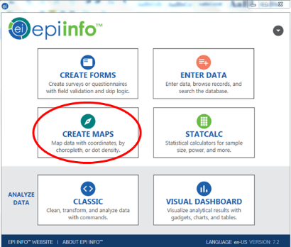
Figure 10.1: Epi Info 7™ main menu, highlighting Create Maps menu option

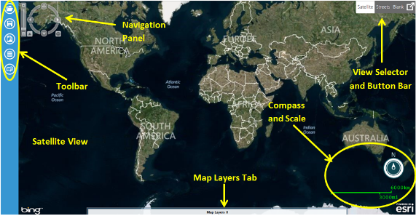
Figure 10.2: Epi Map main window workspace

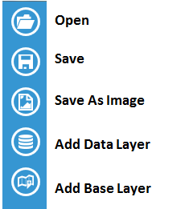
Figure 10.3: Epi Map toolbar with icons defined

View Settings
The default setting in the main window is satellite view (shown in Figure 10.1). The satellite view displays national boundaries, major roadways and geographic markings, as well as regional topography. To change the view setting, click on the Streets or Blank button bar at the top right corner of the screen. The street view displays similar geographic landmarks, roadways and boundaries without the region’s topography. The blank view displays an empty canvas, which is beneficial when working with custom boundary files or adding base layers (see the Base Layers section). You can also opt to view Full Screen by clicking the block with the arrow in the Satellite/Streets/Blank button bar.

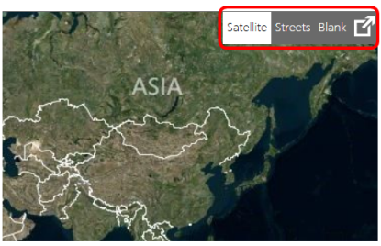
Figure 10.4: Epi Map main window, illustrating location of view selector button bar

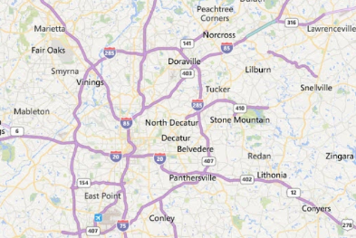
Figure 10.5: Sample streets view

Navigation Tools
To zoom in and out on a location, place the mouse over the desired location and rotate (or scroll) your mouse wheel forwards or backwards respectively. You can also zoom in or out by using the navigation panel at the top left corner of the screen. There is a bar in the far left with a + at the top and a – at the bottom. Click the + to zoom in or the – to zoom out; or, click and drag the bar located in between the + and – to adjust the zoom. To the right of the zoom option is a compass.
Clicking on the arrows representing north, south, east and west will move the map location in the selected direction. You can also click and drag the map to adjust the screen. To rotate the view, click and drag the navigation panel compass wheel until the map view meets your specifications. The navigation panel will be light gray while you are working in other parts of the map, but will “brighten” to white when you mouse over it.

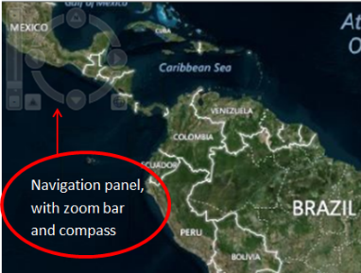
Figure 10.6: Epi Map main window, illustrating where the navigation panel is located

Basic Functions
The map window toolbar contains the following tools to help create a meaningful representation of your data:
- Add marker
- Scale bar
- Add zone
- Add label
- Remove all layers
You can access these basic functions from the main map window by pressing the right click button on your mouse anywhere on the map canvas (called a “right click”).
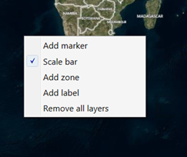
Figure 10.7: Basic functions menu in Epi Map

Add Marker
A marker identifies a point of interest by placing a symbol on the map. Symbols are available in various shapes and sizes to identify multiple points of interest.
- Right click on the main map window in the location where you would like to place the marker. A menu appears displaying the available options.
- Select Add marker.
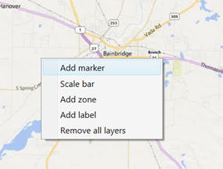
Figure 10.8: Basic functions menu, with “Add marker” option highlighted
- Select a Style from the Style drop-down list for the marker. The style will determine the marker’s shape on the screen.
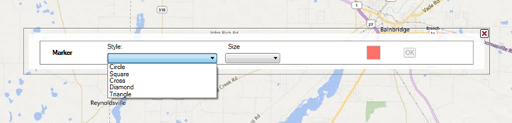
Figure 10.9: Add marker drop-down illustrating various marker styles
- Select the Size of the marker from the Size drop-down list. The smallest marker size available is 10, while the largest is 30.
- Select the Color of the marker by clicking on the red Point Color button to the right of the dialog box.
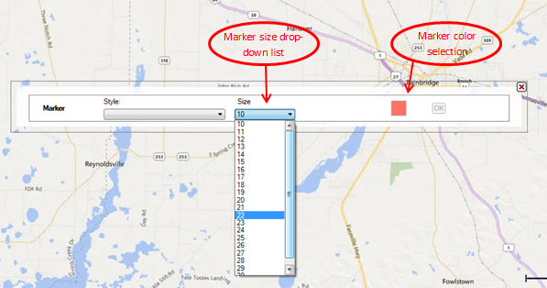
Figure 10.10: Marker size drop-down menu and marker color selection option
- Click OK. The example illustrated below is a diamond-shaped marker of size 20 in red.
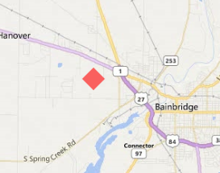
Figure 10.11: Marker displayed in map window

Scale Bar
The Scale bar option in the basic functions menu tells Epi Map whether to display or not display the scale bar in the lower right hand corner of the main map window.

Add Zone
A zone identifies a circular region on the map. This is useful when highlighting an area that centers on a point of interest or specifying an area with public health implications. Zones can be of varied size and color, but are limited to a circular shape.
- Right click on the main map window in the location where you would like to place the center of the zone.
- Select Add zone.
- Enter the desired Radius and Units, For instance, if you want a zone that is 1,000 meters in diameter, you would enter “1,000” in the Radius box and select “Meters” in the Units drop-down. Epi Map will “drop” the zone with the radius starting at the point where you right clicked to add the zone.
- Choose a zone Color by clicking the colored box and selecting your desired color.
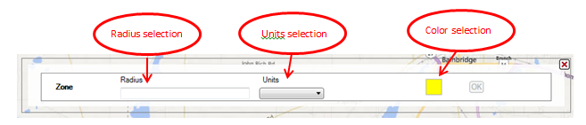
Figure 10.12: Zone radius, units, and color selections
- Click OK. In this example, the zone is 1,000 meters in diameter and yellow in color.
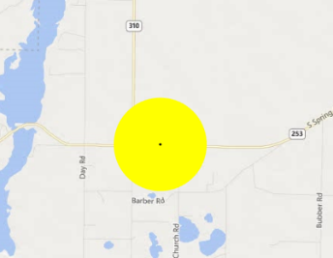
Figure 10.13: Zone displayed in map window
Note: Zones will appear distorted when placed closer to the north and south poles due to the area being re-projected from the globe onto a flat surface.

Add Label
- Right click on the main map window in the location where you would like to place the label.
- Select Add label.
- Enter the label you would like to display in the textbox. Click the Font radio button next to the Font textbox to select the desired Font. The Font radio button will open a list of possible fonts from which to select.
- Choose a label Color by clicking the colored box and selecting your desired color.
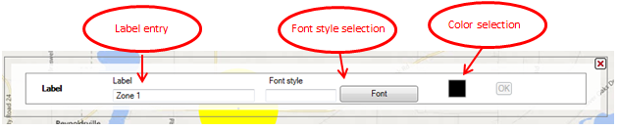
Figure 10.14: Label entry box and font and color selections
- Click OK. In this sample, the label is 16-point Arial font in blue.
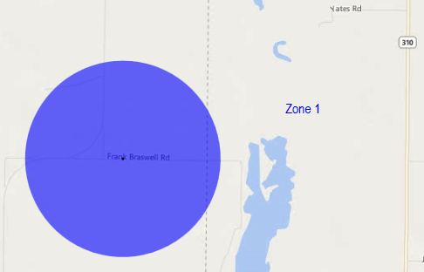
Figure 10.15: Label displayed in map window

Remove All Layers
Markers, zones, and labels are referred to as “layers” or “data layers.” To clear the main map window of all layers, right click on the map and select Remove all layers.

Save Maps as Map File
Maps may be saved as either an image file (*.png) or an Epi Info™ 7 Map File (*.map7). The map file format saves the map along with the underlying data layers. An Epi Info™ 7 Map File can only be opened using the Epi Info™ 7 software. An image file (*.png) can be opened with any image-viewing program (e.g., Microsoft Paint). When opened, the map file will automatically update the map based on any changes to the dataset. Create and save the map file by clicking on the Save icon in the Epi Map toolbar.
- Click the Save button. A Save As dialog box opens.
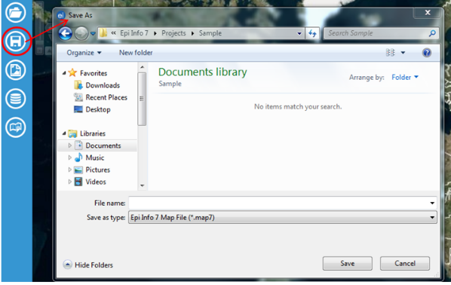
Figure 10.16: Save button and Save As dialog box
- Choose a file destination from the folder drop-down list at the top of the dialog box and type the desired file name in the File name box. The map is saved in the *.map7 file format, which can be opened later by Epi Info™.
- Click the Save button. A Save Successful dialog box appears.
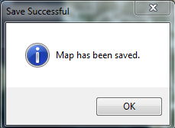
Figure 10.17: Dialog window confirming save was successful
- Click OK to exit.

Save Maps as an Image
The image format saves only the map image in a *.png file format. This image file can be inserted into documents or opened with a multitude of software applications. Save the map as an image by clicking on the Save as Image button in the Epi Map toolbar.
Note: The Epi Info™ software will not open or edit a map saved in image format.
- Click the Save as Image button. A Save As dialog box appears.
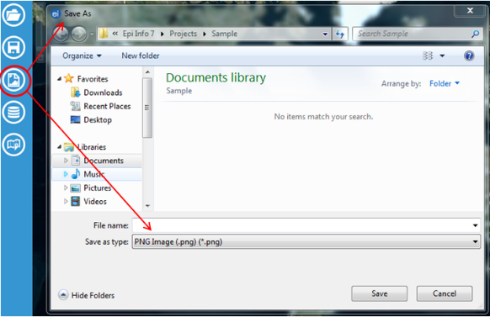
Figure 10.18: Save As image button and resulting Save As (*png) dialog box
- Choose a file destination from the folder drop-down list at the top of the dialog box and type the desired file name in the File name box. The map is saved in the *.png file format, which can be opened later with an image software application.
- Click the Save button. A Save Successful dialog box appears.
Figure 10.19: Save As image button and resulting Save As (*png) dialog box
- Click OK to exit.

Open Maps
Epi Map will only open files in the Epi Info™ 7 Map (*.map7) file format. To open a map file, click the Open button in the Epi Map toolbar and select the desired file by clicking on it once.
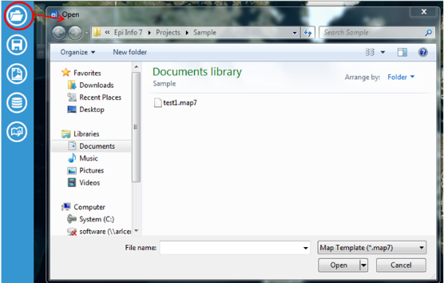
Figure 10.20: Open button and resulting file dialog box
Click Open. The map file updates and displays in the main map window.

Adding a Data Layer
Epi Map offers the option to add Data Layers; that is, to use layering to create different map views and ways of viewing the related data. Epi Map offers four types of Data Layer:
- Choropleth – areas are shaded or colored in proportion to a measurment or variable
- Dot Density – dots show the presence of a feature, but not specific locations
- Case Cluster –coordinates of cases are shown clustered when zoomed out
- Spot Map – shows the coordinates of specific points of interest

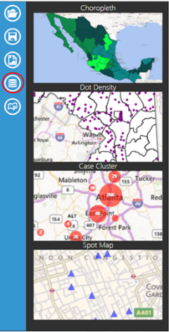
Figure 10.21: Data layer button and resulting list of options

Case Cluster
Case Cluster layer displays case locations on a map based on geographic coordinates. Each dataset used to create a case cluster must contain numeric fields that Epi Map can designate as latitude and longitude. The software has the geocoding capability; that is, it can convert a street address into latitude and longitude coordinates. If geocoding is not applied, a street address alone will not be sufficient to create a case cluster. For additional information on geocoding, refer to the Form Designer section of this user guide.
In the main map window, large case clusters appear as bigger circles with the total case count contained inside of them. Individual cases appear as single dots without a case count designation. The example below demonstrates how to create a case cluster map in street view with sample Epi Info 7 ™ data from the E. coli project folder.
- Select Add Data Layer from the toolbar.
- Select Case Cluster from the drop-down list.
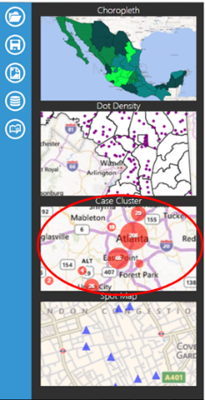
Figure 10.22: Case Cluster selection in list of Data Layers options

- The Case Cluster layer dialog box appears.
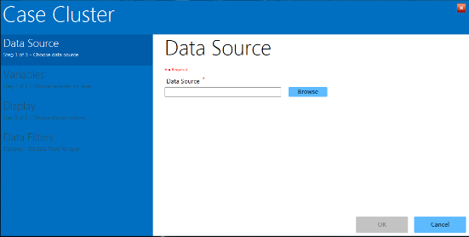
Figure 10.23: Case Cluster layer
- Selecting a Data Source is the first step in the Case Cluster process. Click the blue Browse button located next to the blank Data Source line in the Data Source menu in the Case Cluster dialog box (Figure 10.23).
- A Select Data Source dialog window will open.

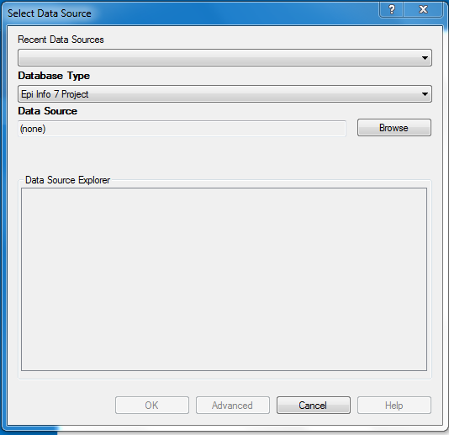
Figure 10.24: Select Data Source dialog box
- Select the appropriate database option from the Database Type drop-down list. There are multiple database types available in the drop-down list, and it is imperative that you select the one that matches the file format you are adding to Epi Map. For this demonstration, the default Epi Info 7 Project option is used. (Note: If you are using a data source you have worked with in Epi Map recently, you can use the Recent Data Sources drop-down to select that specific database.)
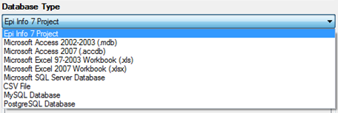
Figure 10.25: Database Type drop-down menu
- Once you have selected the appropriate database type, click on Browse next to the Data Source field. This will open a list of files associated with the database type you have selected.
- Double-click the file and/or project name to select it. For this demonstration, select the Ecoli project by double-clicking the Ecoli folder and then double-clicking the Ecoli.prj database.
- Once you have selected a database, its name will appear in the Data Source field and the associated project data will be listed in the Database Explorer window.
- In the Database Explorer window, select the project data you would like to map. For this example, select the Food History form. Click OK.
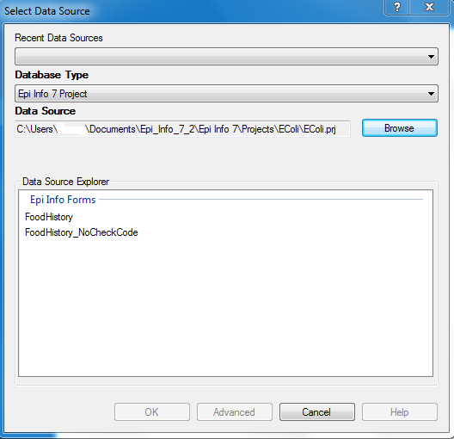
Figure 10.26: Data Source Explorer dialog box
- Select Latitude from the Latitude drop-down list.
- Select Longitude from the Longitude drop-down list.
- Click OK.
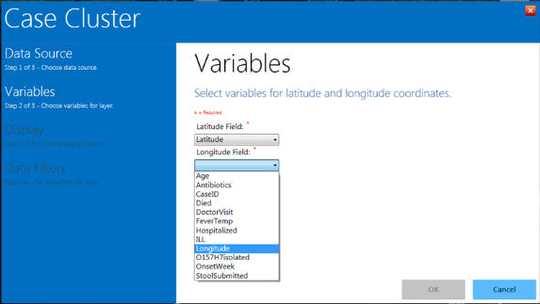
Figure 10.27: Latitude and Longitude drop-down lists in the Case Cluster layer
- Epi Map will automatically take you to the Display options, where you can choose a color and legend title for your clusters. Enter your desired legend name in the Legend Description box. The Color Representation block is blue by default. Clicking the small blue square will pop up the Color options chart, from which you can select standard or custom colors.
- For this example, enter Legend Example for the Legend Description and select red as the cluster color.
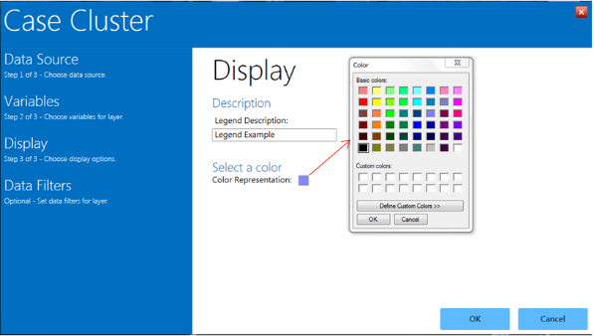
Figure 10.28: Display options in Case Cluster
- Click OK.
- The Case Cluster layer closes and returns to the map. Red circle “clusters” appear in the appropriate locations, with the number of cases in the center of each circle.
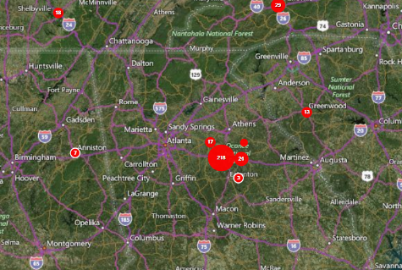
Figure 10.29: Case Cluster results
- As the view zooms in, case clusters separate into smaller clusters and individual cases appear as single red dots.
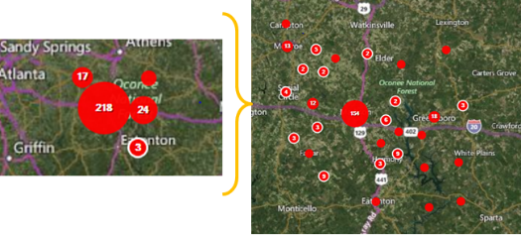
Figure 10.30: Case Cluster zoom
- Moving the mouse over a small case cluster (less than 12 records) will “flare” the cluster. The number seven at the center of the cluster in this example represents seven different cases. When the mouse is over the case cluster, seven smaller dots appear, each representing one of the records inside that cluster. This is useful if the same household contains multiple cases.
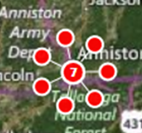
Figure 10.31: Expanded case cluster
- Hovering over the Map Layers bar at the bottom of the map will scroll the bar open and display current map layers (e.g., Legend Description, fields).
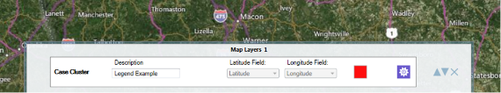
Figure 10.32: Map Layers bar at bottom of map window

Data Filtering in Epi Map
Data filters in Epi Map are used to select a subset of data by specifying and applying certain conditions. This allows the user to show the effect of a variable on the geographic distribution of cases. To access the data filter tool, move your cursor over the Map Layers bar at the bottom of the main map window as described in the previous section. In this example, there is currently one case cluster layer, which is in red and does not contain any filters.
The following example demonstrates how to apply a filter to the Age variable in the data layer from the previous example.
- In the Map Layers bar, click the Edit data layer tool, which is circled in red in Figure 10.33.
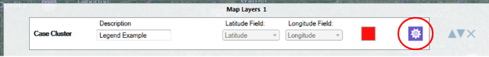Figure 10.33: Edit data layer icon in Map Layers tab at bottom of map window
- The Case Cluster layer opens. Select Data Filters from the list of options in the left-hand menu.
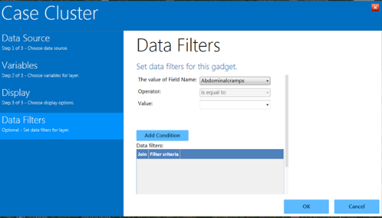
Figure 10.34: Data Filters menu in the Case Cluster layer
- From the drop-down list labeled The value of Field Name, select Age.
- From the Operator drop-down list, select is less than.
- Enter 21 into the Value textbox.
- Click Add Condition. One row defining this filter is automatically added to the Data filter table.
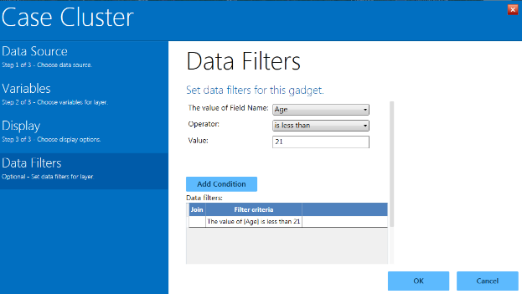
Figure 10.35: Data filters menu with one filter added (age less than 21 years)
- Click OK. The map refreshes to display only cases in which the patient’s age is less than 21 years.
- A filter can be removed by scrolling down below the Data filters window, highlighting the desired filter, and clicking Remove selected. Clicking Clear all conditions removes all filters.
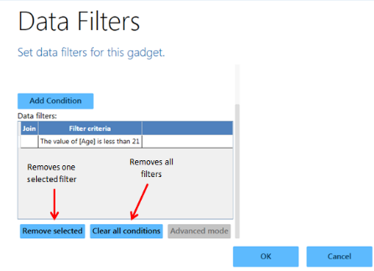
Figure 10.36: Options to remove one selected or all Data filters

Visualizing Multiple Data Layers (Additional Data Layers)
Filters are a powerful tool for sorting data. In certain instances, however, it is best to display the full dataset in groupings displayed in different layers. This requires separating the data, by filtering on more one or more conditions for each layer. After completing the steps to this point in the user guide, the example map displays the patient population that is less than 21 years of age. To create a map with one or more layers, another data layer is needed to show an additional age group in the patient population. In the following example, this is achieved by adding another case cluster data layer with a filter based on the patient’s age. Blue clusters will represent the records that meet the specified condition.
- Select Add Data Layer from the toolbar.
- Select Case Cluster from the drop-down list.
.
- Follow the Data Source selection steps from the previous Case Cluster section to select the Ecoli.prj folder and the Food History form in the Data Source Explorer.
- Select Latitude from the Latitude drop-down list.
- Select Longitude from the Longitude drop-down list.
- Enter Legend Example2 in the Legend Description box. Leave the color as the default blue.

- Click the Data Filters option in the left-hand menu.
- The Data Filters menu appears. In the drop-down for The value of Field Name is, select Age.
- From the Operator drop-down list, select is greater than or equal to.
- Enter 21 into the Value textbox.
- Click Add Condition.
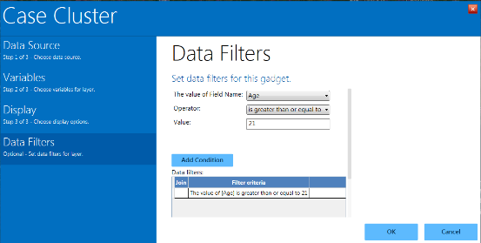
Figure 10.37: Second data filter added to case cluster
- Click OK.
- The map window displays both age group data filters by color.
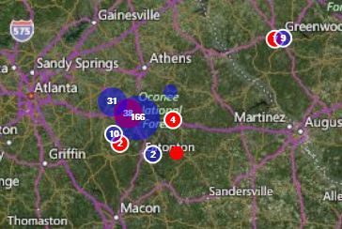
Figure 10.38: Example of case clusters filtered by two age groups
The blue clusters represent cases in which the patient is 21 years of age or older, while the red clusters represent cases in which the patient is less than 21. Epi Map tool allows for multiple age groupings and can also filter the dataset based on other variables (e.g., whether the patient is male or female, foods eaten, etc.).
Note that the Map Layers bar at the bottom of the screen displays a (2) instead of a (1). This indicates that there are two different layers with corresponding filters. The properties of each layer can be viewed by clicking the purple gear icon on the right-hand side (this opens the full Case Cluster menu). The order of layers can be changed using the gray arrows, and layers can be removed fully by clicking the “x” at the far right of the bar.

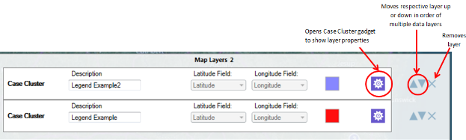
Figure 10.39: Map Layers bar illustrating two case cluster data layers and some of the tools to work with each by two age groups

Time Lapse
When a case cluster layer is added to Epi Map, the tool displays all cases contained in the dataset (or, if a filter is applied, all cases that meet the selected filter criteria). The Time Lapse tool creates a dynamic environment that illustrates how the dataset transforms over time. To enable this feature, use a dataset with a time variable.
- Add a Case Cluster data layer (see Adding a Data Layer). Use the Food History form in the E. coli project for the following example. Select Latitude as the latitude variable and Longitude as the longitude variable in step 2 of the data layer process.
- Once the data layer is added, the Create Time Lapse icon will appear in the left-hand toolbar. Click the icon.
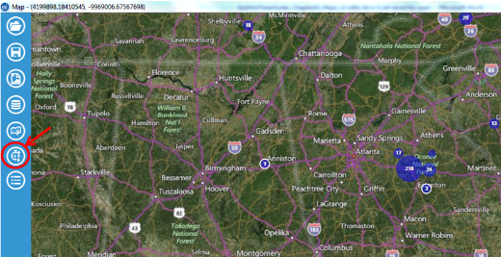
Figure 10.40: Create Time Lapse icon on toolbar
- Select the OnsetDate from the Time Variable from the drop-down list. Click OK.
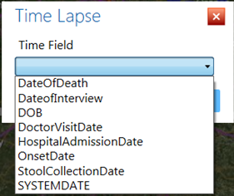
Figure 10.41: Configure Time Lapse dialog box
- The system will add a timeline to the map illustrating the start and end dates found in the dataset. In this example, data in the dataset start (first onset date) on 4/19/2011 and end 4/20/2011 (last onset date).
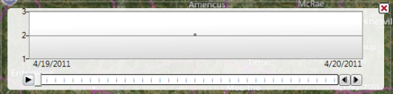
Figure 10.42: Timeline resulting from range of time in the dataset
- To watch the time lapse progression of the symptom onset date over time, click the Run button (single right-pointing arrow at the far left of the timeline).
- The main map window clears and begins adding the cumulative number of cases respective to the timeline. The figure below displays the number of cases in the dataset from 4/19/2011 to 5/13/2011 (end date is displayed at the lower right of the timeline).
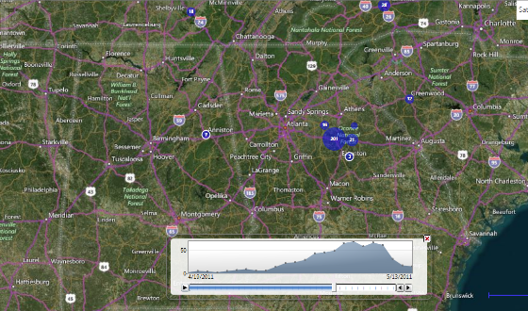
Figure 10.43: Time Lapse display
- The distribution of cases displays at the bottom of the screen.
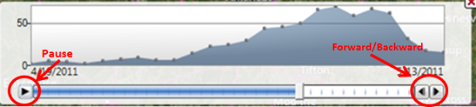
Figure 10.44: Time series distribution with pause and forward/backward buttons highlighted

Creating Choropleth and Dot Density Maps with Boundaries
Epi Map can create a choropleth or dot density map by combining a dataset with three boundary formats: shapefile, map server, or KML (Keyhole Markup Language) (descriptions of each format follow). This is the map/boundary format compatibility:
- Shapefile—an Esri vector data format for location, shape and geographic attributes
- Map server—an Open Source repository for map images and vector data
- KML—an XML notation for geographic annotation and visualization
The boundaries are independent of the dataset but are joined with database keys.
Note: The dataset and boundary file must contain the proper database keys and the user must designate the proper key from each drop-down list to create a choropleth or dot density map.
Key descriptions are as follows:
- Feature Key—designates the variable in the boundary set that will match a corresponding variable in the dataset.
- Data Key—designates the variable in the dataset that will match a corresponding variable in the boundary set.
- Value Field—designates the value being displayed.
Shapefiles
A shapefile stores non-topological geometric and spatial information in vector format. These files are simple to use but lack complex data elements. Various sources attach additional information or tables to shapefiles for more advanced analysis.
KML
KML is an open source specification for describing geographic data. Like shapefiles, KML files contain instructions used by mapping tools to draw boundaries, points, and other feature sets. A benefit to using KML files is that they can be edited using simple text editors.
Map Servers
Map server is a platform used to publish spatial and geographic data to the Internet. One advantage of the map server format is the capability of creating a central repository for mapping data with relational database management systems.

Choropleth Map
A choropleth map uses graded differences in shading or color to display variations of a variable across a geographic area. The color gradient typically spans from one color to another or from a lighter to darker shade of the single color.
The following example demonstrates how to combine a map server feature set for the state of Maryland with the Lyme data set included with Epi Info to create a choropleth map. The boundary format in this case is KML.
Note: This example uses case-based data, where each row in the data set represents an individual case, rather than aggregate data.
- Select Add Data Layer from the toolbar.
- Select Choropleth from the list.
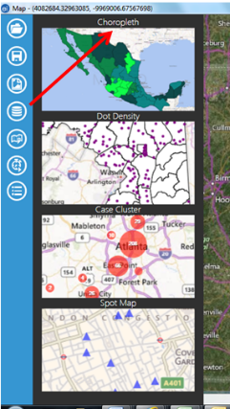
Figure 10.45: Screenshot of choropleth map selection
- The Data Source dialog box appears. Click Browse to open the database options.
- Click Browse next to the Data Source field. Select the Lyme folder and then the Lyme.prj file.
- Select the Case Report form in the Data Source Explorer. Click OK.
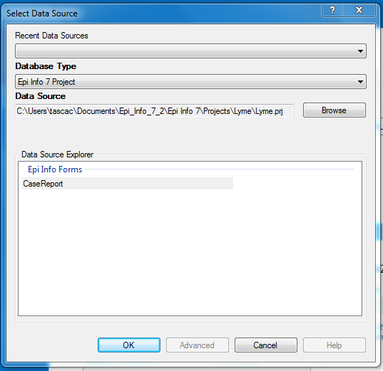
Figure 10.46: Choropleth Data Source dialog box
- Select the KML/KMZ radio button in the Data Source dialog box and click Browse.
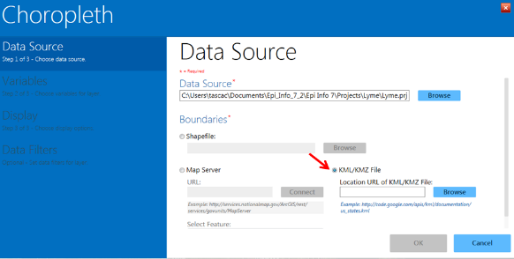
Figure 10.47: KML/KMZ radio button in Choropleth Data Source dialog box
- Click back to the main Epi Info Project folder. Open the KML_Example folder and select the Maryland_Counties.kml file. Click Open.
- In the Data Key drop-down, select County.
- In the Value Field drop-down, select {Record Count}. In the Feature Key drop-down, select County_Name.
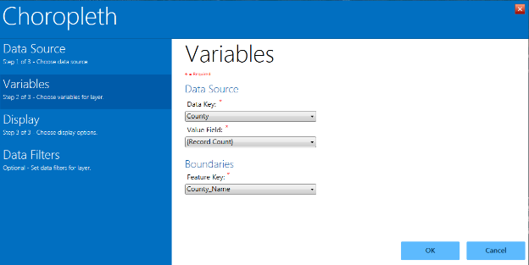
Figure 10.48: Data Source drop-down menus in the Choropleth layer
- In the Display property panel, set the desired display options such as legend title and text (labels). For this example, leave these options blank. You can also select the colors and data ranges to use, including the number of classes into which you would like to divide the data. For this example, leave the default selections. Click OK.
- The choropleth map appears, showing the number of records in the dataset within each Maryland County. Counties with the highest tier of records are dark blue, while counties with the least amount of records are very light blue. Note that the “starting” data category is white, but no data fall into that particular category here.

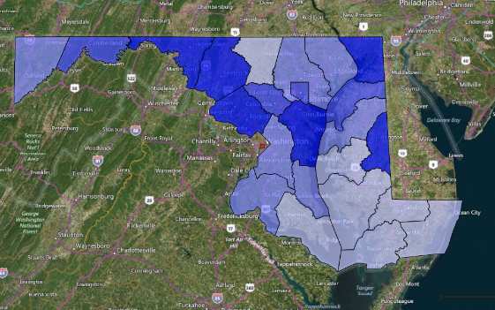
Figure 10.49: Example choropleth map from Lyme disease dataset
- Click on Blank in the upper right of the main Epi Map window to view the choropleth with a white background only.
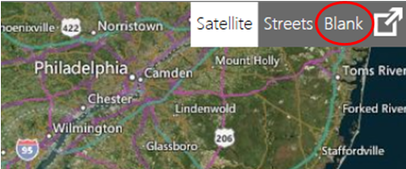
Figure 10.50: Blank selection in main Epi Map main window
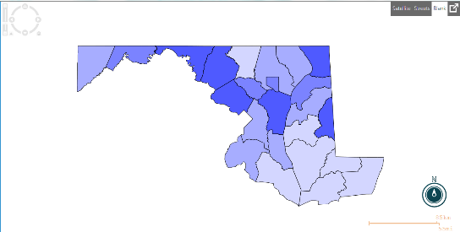
Figure 10.51: Choropleth in Blank view

- To change any of the display options or to add optional data filters, place the mouse over the Map Layers tab located at the bottom of the screen. When the tab scrolls up, click the layer configuration icon to re-open the Choropleth layer.
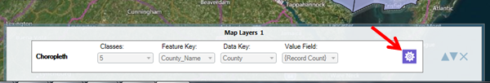
Figure 10.52: Map Layers tab and layer configuration icon

Dot Density Map using Shapefile Boundaries
To display densities across geographic boundaries, select Dot Density from the data layers list. Epi Map will populate the dot density map according to the dot value selected in step eight. Increasing the dot value increases the value each dot represents. The dot density map populates each dot randomly within a set of boundaries to display the density. The example below demonstrates how to create a dot density map with data from a Vital Statistics report published by the Mexico Ministry of Health using a shapefile.
- Select Add Data Layer from the toolbar.
- Select Dot Density from the list.
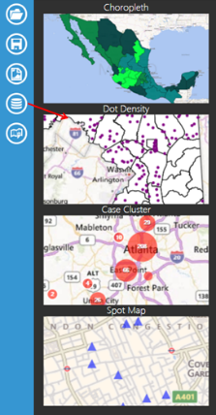
Figure 10.53: Screen shot of Dot Density
selection
- The Data Source dialog box opens.
- Click Browse next to the Data Source field in the main layer dialog box, and then again in the Data Source dialog box. Select the Sample project folder and the Sample.prj file.
- Select the MexMap95 form in Data Source Explorer. Click OK.
- Click Browse next to the Shapefile line. (If the Browse button is grayed out instead of blue, click the Shapefile radio button.)
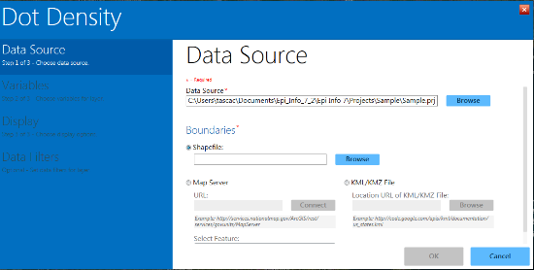
Figure 10.54: Browse Shapefile selection option
- Select MXState.shp in the Sample.prj file.
- Select STATE from the Data Key drop-down list. The data key connects the dataset field, STATE, to the shapefile feature key name.
- Select PerTeenBirths95 from the Value Field drop-down list. This populates the dot density map based on the percentage of teen births in that state.
- Select name from the Feature Key drop-down list. The feature key connects name in the shapefile to the dataset.

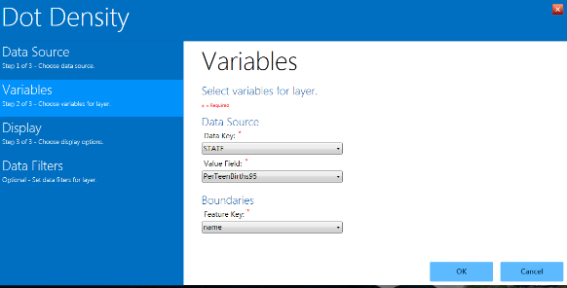 Figure 10.55: Shapefile variable options and boundaries
- Click OK.
- The Display options dialog appears. Options can be selected here for the color of dots in the map and the value each dot should represent (Dot Value). In this example, the dots are associated with the percentage of teen pregnancy in each state. By specifying “1”, each dot will represent a single teen birth percentage point.
- Click OK.
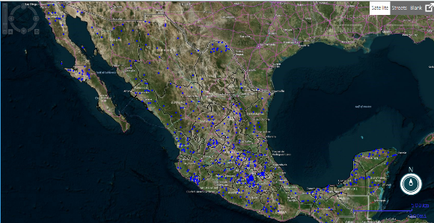
Figure 10.56: Dot Density using shapefile
- The Dot Density map data layer displays on the main Epi Map window. Since one (1) was selected as the dot value, each blue dot represents a single percentage point for the dataset. Areas with a higher concentration of red dots represent a higher percentage of teen births.
- Select Blank view at the top right corner of the main Epi Map window to display the Dot Density map with a white background. You can also select Streets to view the map at the street level.
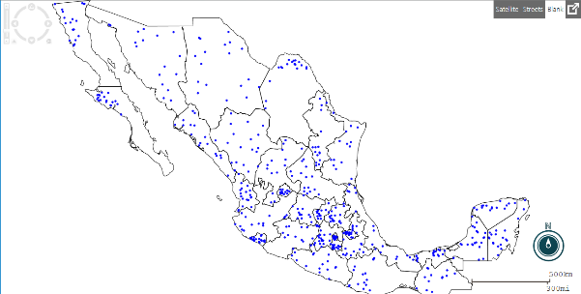
Figure 10.57: Dot Density in Blank View
- To change any of the display options or to add optional data filters, place the mouse over the Map Layers tab located at the bottom of the screen. When the tab scrolls up, click the layer configuration icon to re-open the Choropleth layer.
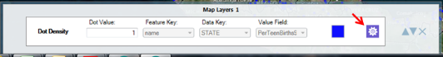
Figure 10.58: Dot Density Map Layers view and layer configuration icon
The three examples shown in the Adding a Data Layer section do not represent every possible combination of map type, database type, and boundary file. Epi Map is capable of mapping all combinations using similar processes.

Base Layer
Base layers are available to enhance the map with additional information beyond of the project data. The previous section explained how to combine information from shapefiles, KML files, and the map server with a dataset to create choropleth and dot density maps. However, additional layers may be necessary to highlight points of interest or boundaries that are not evident in the data layers. You can add more layers to an existing map using the Add Base Layer option from the toolbar.
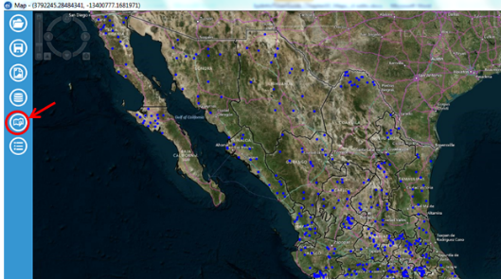
Figure 10.59: Add Base Layer in Epi Map toolbar

KML
The example below displays the storm track taken by Hurricane Katrina.
- From the toolbar at the left hand side of the Epi Map window, select Add Base Layer as shown in Figure 10.59. The Base Layer opens.
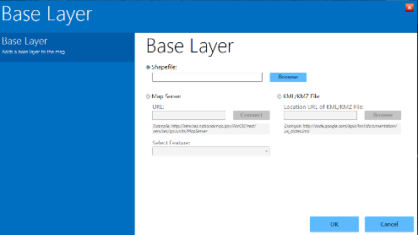
Figure 10.60: Add Base Layer

- Click the KML/KMZ File radio button to “light up” the option to enter or browse for a URL.
- Type the following URL for NOAA’s Katrina tracker: http://ngs.woc.noaa.gov/storms/katrina/kml/katrina_track.kml. The map appears displaying Hurricane Katrina’s track.
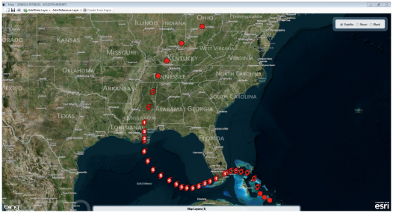
Figure 10.61: KML Reference Layer

Map Server
- From the toolbar at the left hand side of the Epi Map window, select Add Base Layer as shown in Figure 10.59. The Base Layer appears as shown in Figure 10.60.
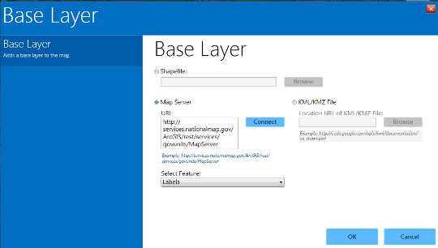
Figure 10.62: KML Reference Layer

- Click the Map Server radio button and enter a Map Server URL into the box. In this example, enter the sample URL shown below the blank URL box and here at
http:/services.nationalmap.gov/ArcGIS/rest/services/govunits/MapServer.

- Select Labels from the Features drop-down menu.The map displays government units identified in the selected map server.

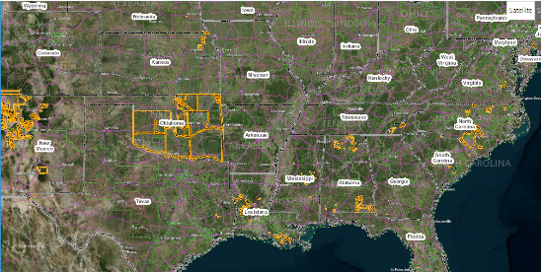
Figure 10.63: Map Server base layer
- Zooming in highlights additional layers of government units, with labels as selected in the Features drop-down.

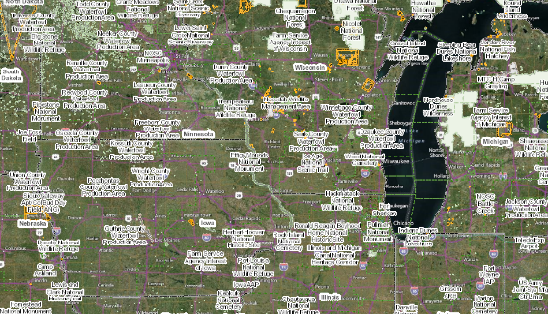
Figure 10.64: Map Server base layer zoomed view

Shapefiles
The example below displays the Mexican state boundaries from the Sample project folder.
- From the toolbar at the left hand side of the Epi Map window, select Add Base Layer as shown in Figure 10.59. The Base Layer appears as shown in Figure 10.60.
- Click the Shapefile radio button and click Browse to the right of the blank shapefile box.
- In the Sample.prj file, select the MXState.shp file.
- Click OK.
- The map will appear, displaying the shapefile boundaries (in this case, Mexican states).
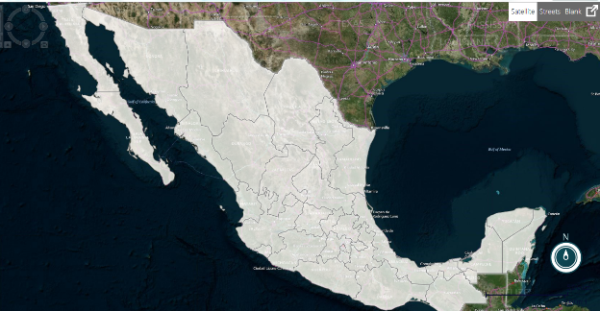Figure 10.65: Shapefile Base Layer

