Appendix A. Notation

- Census tracts are denoted by $i=1,...,I$
- Observations are denoted by $j=1,...,J$ for the $J$
- $y_{j}$ - outcome ($e.g.$ smoking) for observation $j$
- $u_{j}$ - is the census tract for observation $j$
- $w_{j}$ - is the raked sampling weight for observation $j$
- $z_{j}$ - zip code for observation $j$
- $P_{i}$ -True census tract level population prevalence

Appendix B. Imputation of Census Tract
The Department of Housing and Urban Development (HUD) provides the estimated proportion of a zip code's total residential addresses, which fall within each census tract (CT). For example, if zip code $z$ overlaps with 5 census tracts, we would have $p_{z1},p_{z2},p_{z3},p_{z4},$ and $p_{z5}$ where
$$p_{z1}=\frac{number of residential addresses in zip z and CT1}{total number of residential addresses in zip z}$$
and $\sum_{i=1}^{5}{p_{zi}}=1$. We assume that the probability of being from CT $i$ given you are in zip code $z$ is $p_{zi}$.
For observations with missing census tracts, we impute a census tract based on a multinomial distribution with the HUD probabilities ($p_{zi}$). For a single imputation each observation $j$ is assigned to census $i$ creating a set of indices $s_{i}$. The imputation is repeated $D$ times, resulting in $d=1,...,D$ complete observation data sets (no missing census tracts).

Appendix C. Hierarchical Bayesian Model
For each complete data set $d$ our approach is to summarize the data in census tract $i$ via the asymptotic distribution of the estimator of $P_{i}$, which we denote ${\overset{ˆ}{P}}_{i}=\sum_{j∈s_{i}}{w_{j}}y_{j}/\sum_{j∈s_{i}}{w_{j}}$, the Hajek estimator (1) of $P_{i}$, with corresponding variance estimator var$({\overset{ˆ}{P}}_{i})$. In this way the design is acknowledged in both the estimator and the variance. We define the area-level data summary as $x_{i}=log\left[{\overset{ˆ}{P}}_{i}/(1-{\overset{ˆ}{P}}_{i})\right]$ as the empirical logistic transform of ${\overset{ˆ}{P}}_{i}$. This approach constrains the probability to lie in (0,1). The likelihood is then taken as the asymptotic distribution
$$x_{i}|P_{i}∼N\left(log\left[\frac{P_{i}}{1-P_{i}}\right],\frac{\overset{ˆ}{var}({\overset{ˆ}{P}}_{i})}{{\overset{ˆ}{P}}_{i}^{2}(1-{\overset{ˆ}{P}}_{i})^{2}}\right).$$
We employ three-stage models with the first stage given by $x_{i}|P_{i}$ above, which was shown to perform well in a small area estimation context and has been applied to annual zipcode-level BRFSS data (2). When the ${\overset{ˆ}{P}}_{i}=0/1$ we have $\overset{ˆ}{var}({\overset{ˆ}{P}}_{i})=0$ which is problematic in the first stage of our model. In these cases we use the method of moments based on a beta-binomial model described in the supplementary materials of (3) to provide ${\overset{ˆ}{P}}_{i}$ and $\overset{ˆ}{var}({\overset{ˆ}{P}}_{i})$ that are adjusted to be non-zero.
At the second stage of the model we introduce the spatial random effects terms, corresponding to the convolution model of (4), and denote the area-specific parameters as
$$η_{i}=μ+θ_{i}+ϕ_{i}$$
where $μ$ is the overall risk level, $ϕ_{i}|σ_{ϕ}^{2}∼_{iid}N(0,σ_{ϕ}^{2})$ is an independent census tract random effect, and $θ_{i}$ following an intrinsic conditional autoregressive (ICAR) model (5). The ICAR model is a non-parametric, stochastic smoothing model with
$$θ_{i}|θ_{k},k∈ne(i),σ_{θ}^{2}∼N\left({\overline{θ}}_{i},\frac{σ_{θ}^{2}}{n_{i}}\right),$$
where $ne(i)$ indexes the set of neighbors of area $i$, $n_{i}$ is the number of such neighbors and ${\overline{θ}}_{i}=\frac{1}{n_{i}}Σ_{k∈ne(i)}{θ_{k}}$ is the mean of the neighbors.
For the third stage we use assign Gamma priors on the spatial conditional precision $σ_{θ}^{-2}$ and the $iid$ precision parameter $σ_{ϕ}^{-2}$. The rate and shape parameters, 0.5 and 0.008, respectively, were selected such that the 95% range is on the interpretable $σ_{θ}$ and $σ_{ϕ}$ scale of (0.056,4.04). We use an improper flat prior on $α$.

Appendix D. Combining Estimates
Our goal is to describe the posterior distribution of $η_{i}$ given the observed data. We assume $u_{o}$ are the set of observed census tracts and $u_{m}$ are the missing census tracts
$$p(η_{i}|y,z,u_{o})=∫p(η,u_{m}|y,z,u_{o})p(u_{m}|y,z,u_{o})du_{m}≈\frac{1}{D}\sum_{d=1}^{D}{p}(η|y,z,u_{o},u_{m}^{(d)})$$
where $u_{m}^{(d)}∼p(u_{m}|y,z,u_{o})$. In our current implementation $u_{j,m}^{(d)}∼p(u_{j,m}|z_{j})$ is the multinomial distribution based on HUD data, but in principle could involve other covariates.
Given our set of $D$ smoothed estimates of each $η_{i}$ we find the mean posterior estimate
$$E(η_{i}|y,z,u_{o})≈\frac{1}{D}\sum_{d=1}^{D}{{\overset{ˆ}{η}}_{i,d}}={\overset{ˆ}{η}}_{i}$$
where ${\overset{ˆ}{η}}_{i,d}=E(η_{i}|y,z,u_{o},u_{m}^{(d)})$ is the estimated $η_{i}$ from the $d$th complete data set.
Similarly we find a variance
$$V(η_{i}|y,z,u_{o})≈\frac{1}{D}\sum_{d=1}^{D}{V_{i,d}}+\frac{1}{D-1}\sum_{d=1}^{D}{{\left({\overset{ˆ}{η}}_{i,d}-{\overset{ˆ}{η}}_{i}\right)}^{2}}={\overset{ˆ}{V}}_{i}$$
where $V_{i,d}=V(η_{i}|y,z,u_{o},u_{m}^{(d)})$ (the posterior variance of $η_{i}$ based on the $d$th complete dataset). This variance estimate has contributions from within and between the sets of estimates (1).
Finally, estimates for census tract $i$ are derived from expit($\overset{ˆ}{η_{i}}$) and 95% credible intervals are generated using
$$\left[expit\left({\overset{ˆ}{η}}_{i}-1.96×\sqrt{{\overset{ˆ}{V}}_{i}}\right),expit\left({\overset{ˆ}{η}}_{i}+1.96×\sqrt{{\overset{ˆ}{V}}_{i}}\right)\right].$$

Appendix E. Scatter Plots Comparing Direct Estimates with Smoothed Estimates By Sample Size
Point Estimates | CI Width
Direct to Complete Case Smoothed  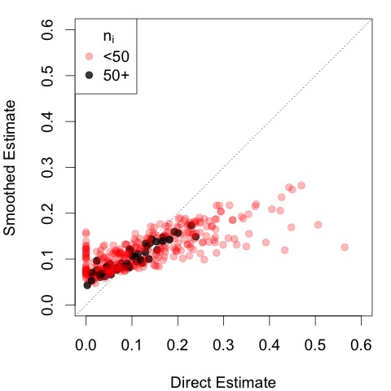 | Direct to Complete Case Smoothed  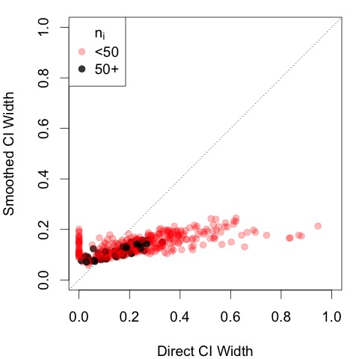
Direct to MI Smoothed  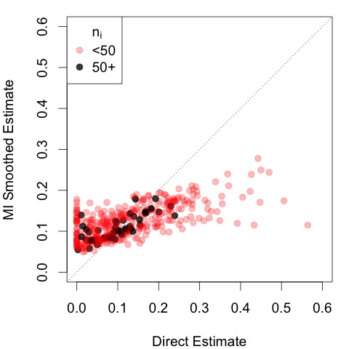 | Direct to MI Smoothed  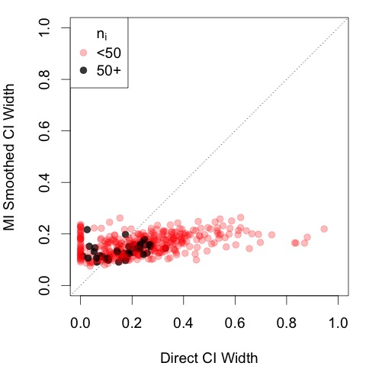

REFERENCES
- Hajek, J. (1971). Comments on a paper by D. Basu. In: Foundations of Statistical
- Inference (eds: V.P. Godambe and D.A. Sprott). Toronto: Holt, Rinehart and Winston.
- Mercer LD, Wakefield J, Pantazis A, Lutambi AA, Masanja H, and Clark SJ. “Space-Time Smoothing of Complex Survey Data: Small Area Estimation for Child Mortality”. Annals of Applied Statistics. 9(4) (2015): 1889-1905.
- Chen, Cici, Jon Wakefield, and Thomas Lumely. "The use of sampling weights in Bayesian hierarchical models for small area estimation." Spatial and spatio-temporal epidemiology 11 (2014): 33-43.
- Besag, Julian, Jeremy York, and Annie Mollié. "Bayesian image restoration, with two applications in spatial statistics." Annals of the institute of statistical mathematics 43.1 (1991): 1-20.
- Rue, Havard, and Leonhard Held. Gaussian Markov random fields: theory and applications. CRC Press, 2005.

