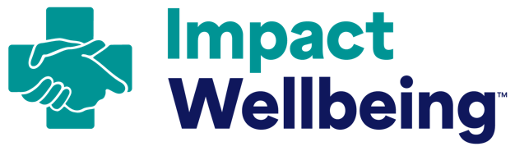
Leadership Rounding Form

How to use this leadership rounding form:
- Use the following form as a starting point to help you expand existing leadership rounds as an opportunity to improve two-way communication with staff. This form draws from the Centers for Medicaid and Medicare Services Leadership Rounding Form.
- Build relationships with staff during your planned rounds by taking the time to listen and respond to your staff’s needs.
- Plan, conduct, and reflect on rounding to have better conversations about wellbeing with staff and hear directly from your workforce. In-person rounding should be a key component of ongoing wellbeing efforts.

Leadership Rounding Overview
Leadership rounding is a process where leaders talk with staff directly about the way their organization functions. This takes place where the staff work, not where leaders work. It allows leaders to both witness hospital processes and meet healthcare workers where they are to gather feedback.
Questions to Consider Before Rounding:
- Which leaders will conduct rounds?
- How frequently will rounds take place?
- What do you want to learn?
- What barriers have already been identified that employees should be asked for their input on?
- How will you document key feedback you hear from staff?
Important Questions to Ask Your Workforce During Rounding:
- What’s going well for you?
- What needs to be improved or worked on?
- How can I help?
- Share information about current wellbeing work and upcoming changes. Ask for input and feedback.
To Do After Rounding:
- Identify frequently noted concerns.
- Prioritize issues.
- Follow up to show responsiveness to hospital staff. Demonstrate how issues were resolved and staff feedback was heard.
- Consider ways to acknowledge employee efforts and contributions to wellbeing.

